The Solar Occultation For Ice Experiment (SOFIE)

Algorithm Theoretical Basis Document
Larry L. Gordleyª, Mark Hervigª, Chad Fish^{b}, James Russell III^{c}, James Cook^{b}, Scott Hanson^{b}, Andrew Shumway^{b}, Scott Bailey^{d}, Greg Paxtonª, Lance Deaverª, Tom Marshallª, John Burtonª, Brian Magillª, Chris Brownª, Earl Thompsonª, and John Kemp^{b}
ªGATS Inc., Newport News, VA, 23606, USA.
^{b}Space Dynamics Laboratory, Utah State University, Logan, UT, USA.
^{c}Hampton University, Hampton, VA, 23668, USA.
^{d}Virginia Technical Institute, Blacksburg, VA, 24061, USA.

Abstract. The Solar Occultation For Ice Experiment (SOFIE) was launched onboard the Aeronomy of Ice in the Mesosphere (AIM) satellite on 25 April 2007, and began science observations on 14 May 2007. SOFIE conducts solar occultation measurements in 16 spectral bands that are used to retrieve vertical profiles of temperature, O₃, H₂O, CO₂, CH₄, NO, and polar mesospheric cloud (PMC) extinction at wavelengths from 0.330 to 5.006 μm. SOFIE performs 15 sunset measurements at latitudes from 65° - 85°S and 15 sunrise measurements at latitudes from 65° - 85°N each day. This work describes the SOFIE instrument, measurement approach, and retrieval results. SOFIE measurement/retrieval performance is discussed for observations from the northern summer of 2007.

Revision History
Version 1.1, February 7, 2008

Table of Contents
1.0. Introduction
1.1. Purpose
1.2. Scope
1.3. Experiment Objectives
2.0. Measurement Approach
2.1. PMC Extinction Retrieval
3.0. Measurement Geometry
4.0. Instrument Description
4.1. Optical Design
4.2. Signal Conditioning Electronics
4.3. Sun Sensor
5.0. Instrument Calibration and Performance
5.1. Noise and Background
5.2. Response Linearity
5.3. Field of View
5.4. Spectral Response
5.5. Time Response
5.6. Sun Sensor
6.0. In-orbit Calibration
7.0. Data Processing / Measurement Inversion
7.1. Level 1
7.2. Level 2
8.0. In-Orbit Performance
9.0. Retrieval results
10.0. Summary
11.0. References
12.0. Acronyms and abbreviations
13.0. List of applicable documents and web sites

List of Figures
Fig. 1. Solar occultation measurement geometry.
Fig. 2. PMC scattering, absorption, and extinction spectra.
Fig. 3. Predicted SOFIE measurement coverage for the first year on orbit.
Fig. 4. The SOFIE line-of-sight passing through an atmospheric shell at 83 km altitude.
Fig. 5. SOFIE optical system block diagram.
Fig. 6. Electrical block diagram.
Fig. 7. Dimensions of the SOFIE sun sensor focal plane array.
Fig. 8. Modeled angular distribution of relative solar intensity.
Fig. 9. Nonlinearity calibration results.
Fig. 10. Vertical FOV relative response functions.
Fig. 11. FOV elevation boresight location.
Fig. 12. Relative spectral response for bands 1-16.
Fig. 13. Temperature sensitivity of bandpass center location and width.
Fig. 14. Location of solar image as determined by the SOFIE sun sensor.
Fig. 15. Average profiles of temperature, H₂O, 3.064 μm extinction, O₃, and CH₄.
Fig. 16. Time versus height cross sections of T, H₂O, 3.064 μm ice extinction, O₃, and CH₄.
Fig. 17. Temperature profile retrieved from SOFIE refraction angle measurements.

List of Tables
Table 1. SOFIE Channel Characteristics.
Table 2. Calibration Results.
Table 3. SOFIE retrieval characteristics

1. Introduction

1.1. Purpose
This Algorithm Theoretical Basis Document (ATBD) provides an overview of the Solar Occultation For Ice Experiment (SOFIE) experiment which is part of the Aeronomy of Ice in the. Mesosphere (AIM) mission. The scientific rational behind the experiment is thoroughly described as well as how the SOFIE objectives have been meet through instrument design, testing and careful analysis.

1.2. Scope
This document describes SOFIE mission objectives; instrument design; important flight operations considerations; mathematical background; Level 1 processing steps such as signal corrections, pressure registration, and focal plane array analysis; Level 2 retrieval software; required inputs; data products; and hardware.

1.3. Experiment Objectives
SOFIE is one of three science instruments onboard the AIM satellite. The AIM goal is to characterize PMCs and the environment in which they form (Russell et al., 2008). PMCs, also known as noctilucent clouds (NLCs), exist near 83 km altitude during polar summer and are visible with the naked eye shortly after sunset or before sunrise. PMCs are observed to vary over latitude, between hemispheres, and on seasonal and decadal time scales. Even more intriguing is the mounting evidence for long-term increases in PMC activity. Composed of ice particles (Hervig et al., 2001), PMCs are sensitive to atmospheric temperature, humidity, and the availability of ice nuclei. The observed increase in PMC frequency and brightness towards the poles is well correlated with decreasing temperatures. Many observations indicate that PMCs are brighter and more numerous in the northern hemisphere than in the south (e.g. DeLand et al., 2003). Hemispheric PMC differences are attributed primarily to colder temperatures in the north, since mesospheric humidity appears to be nearly identical in the north and south (Hervig and Siskind, 2006). Decadal variability in PMCs has been correlated with the 11-year solar cycle (e.g., Gadsden, 1998), during which solar intensity at certain wavelengths can change by a factor of two. Because water vapor is destroyed by solar Lyman alpha radiation and increased solar intensity enhances diabatic heating, a warmer and drier mesosphere at solar maximum should result in fewer and dimmer PMCs. These expected relationships were recently quantified using measurements from the Halogen Occultation Experiment (HALOE) (Hervig and Siskind, 2006). Finally, long-term changes in PMC characteristics are expected to result from anthropogenic climate forcing (Thomas, 1996). Increasing atmospheric carbon dioxide and methane have been linked to decreasing temperatures and higher humidity in the mesosphere. Since these changes are qualitatively consistent with increased PMC activity, PMCs were proposed as a visible indicator of atmospheric change (Thomas, 1996). PMCs are occurring more frequently, becoming brighter, and are now being sighted at middle latitudes for the first time (e.g., Wickwar et al., 2002). Documenting long-term PMC changes and substantiating the connections between PMCs and climate change has been challenging due to limitations in the observations of PMCs and their environment. While compelling evidence for long-term change exists (e.g., Shettle et al., 2002), open questions concerning the drivers behind PMC formation and variability have roused debate over the interpretation of these findings (von Zahn, 2003; Thomas et al., 2003).
Increased understanding of natural processes and variability in the mesosphere is essential to developing a clearer picture of PMC changes on a variety of scales. SOFIE solar occultation measurements (Fig. 1) add to this understanding by providing vertical profiles of temperature, trace gas abundance (O₃, H₂O, CO₂, CH₄, and NO), and PMC extinction at wavelengths from 0.330 to 5.006 μm. The SOFIE measurement suite is conducted simultaneously and the key measurements of temperature, H₂O, and PMCs are independent of each other, two critical factors in the study of PMCs. The pair of measurements comprising the water vapor channel are located at the spectral minimum for ice extinction (Fig. 2), rendering the water retrieval insensitive to PMCs. Nature’s placement of strong water bands at this ideal location in the ice spectrum is invaluable to the AIM mission. The SOFIE instrument draws on heritage from the highly successful HALOE experiment which conducted solar occultation measurements from October 1991 thru November 2005.

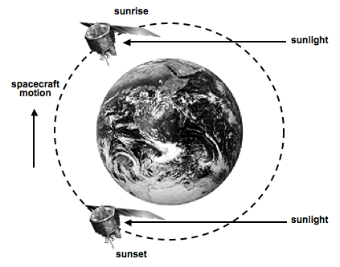 | Fig. 1. Solar occultation measurement geometry depicting solar rays passing through the limb of the Earth’s atmosphere during spacecraft sunrise and sunset.

2. Measurement Approach
The SOFIE measurement objectives are to characterize PMC particle characteristics including mass density and size distribution, in addition to temperature (T) and H₂O, O₃, NO, and CH₄, abundance in the cloud environment. To realize these objectives the measurements must achieve high sensitivity and high vertical resolution (< 2.0 km). High sensitivity to ice mass density is obtained from measurements at the ice absorption peak near 3.0 μm (Fig. 2). Sensitivity to particle size is obtained through the combination of ice absorption measurements in the infrared (IR) and scattering measurements at wavelengths shorter than ~1.5 μm. While the non-uniform and transient nature of PMCs can induce biases in a single measurement because the measurement retrievals assume spherical symmetry, multiple and simultaneous (in time and space) measurements contain identical geometric errors. As a result, geometric errors are eliminated when deriving ice properties that can be described in terms of the ratio of extinctions at different wavelengths. In addition, the dynamic nature of the PMC environment requires simultaneous T, gas, and ice measurements. The need for spatial and temporal simultaneity suggests a pupil imaging system, and vertical resolution requirements tend to favor limb measurements over scanning systems such as interferometers. Furthermore, ozone measurements extending into the lower thermosphere require strong absorption as provided by the Hartley band near 0.3 μm. The desired measurement spectral range (0.3 to 5 μm) eliminates most spectrometer approaches. These requirements, in addition to the need for a system of moderate cost and size with signal-to-noise in excess of 10⁵, led to a broadband solar occultation approach.

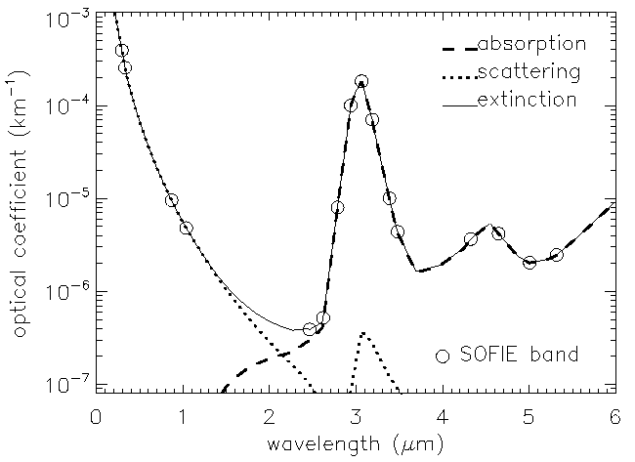 | Fig. 2. PMC scattering, absorption, and extinction spectra modeled using the average PMC size distribution from von Cossart et al. [1999]. The position of SOFIE bands is indicated.

SOFIE measures vertical profiles of limb path atmospheric transmission within 16 spectral bands between 0.29 and 5.32 μm wavelength. Occultation measurements are accomplished by monitoring solar intensity as the satellite enters or exits the Earth’s sunlit side (spacecraft sunrise or sunset, see Fig. 1). The ratio of solar intensity measured through the atmosphere (V, endoatmospheric) to the intensity measured outside the atmosphere (V₀, exoatmospheric) yields broad band atmospheric transmission, τ = V/V₀, which is the basis for retrieving the desired geophysical parameters. Because the endoatmospheric and exoatmospheric intensities are measured using the same electro-optical system, absolute response errors are eliminated in the resulting atmospheric transmission measurements.
SOFIE performs broadband differential absorption measurements using eight channels. Each channel consists of two broadband radiometer measurements, one located in a wavelength region of strong absorption (V_{S}) and one in a spectrally adjacent region of weaker absorption (V_{W}) (see Table 1). SOFIE also measures the radiometer difference signal, which is amplified by an electronic gain, G_{ΔV},
ΔV = (V_{w} – V_{s}) G_{ΔV} (1)
As demonstrated below, the difference signal is a nearly direct measure of the strong band integrated extinction. While a simple radiometer measurement can be sufficient to retrieve gas mixing ratios in the lower mesosphere and stratosphere, SOFIE seeks to characterize the tenuous regions extending into the lower thermosphere. At these altitudes, atmospheric densities and gaseous abundances are low and the corresponding signals can be overwhelmed by a variety of measurement errors. However, common mode errors are nearly eliminated in the difference signal measurements. This benefit is realized because a variety of solar, atmospheric and instrumental effects are nearly equal and positively correlated in the strong and weak bands, and therefore removed by electronically differencing the band pairs. Another benefit is the electronic gain applied to the difference signals, which allows digitization-limited measurements to achieve a precision consistent with the detector noise.
The measured signal for a hypothetical single ray observation (i.e. perfectly resolved spatially) can be written as an integral in wavelength (λ):
$V=C\int_{λ}{G(λ)S(λ)t(λ)dλ}$ (2)
where Γ(λ) is the instrument spectral response function, S(λ) is the solar source function, τ(λ) is atmospheric transmission, and C is an instrument response constant. We define the band-integrated transmission as
$\bar{t}=\frac{V}{V_{0}}$ (3)
For a band pair comprising a SOFIE channel, the measurements are mathematically balanced during data analysis so that the weak and strong exoatmospheric signal are equal, V_{0,W} = V_{0,S}. As a result ΔV divided by V₀ yields the transmission difference:
$\frac{DV}{V_{0}}=\frac{V_{W}−V_{S}}{V_{0}}={\bar{t}}_{W}−{\bar{t}}_{S}$ (4)
For optically thin conditions (2) can be approximated by:
$V=C\int_{λ}{G(λ)S(λ)[1−s(λ)]dλ}$ (5)
where σ(λ) is the limb path optical depth and τ(λ) = exp(-σ(λ)) ≈ 1 - σ(λ). From (3) $\bar{t}$≈ 1 - σ(λ). In the absence of clouds ${\bar{s}}_{W}$ << ${\bar{s}}_{S}$, and (4) becomes
$\frac{DV}{V_{0}}={\bar{t}}_{W}−{\bar{t}}_{S}={\bar{s}}_{S}−{\bar{s}}_{W}»{\bar{s}}_{S}$ (6)
In the presence of clouds ${\bar{s}}_{S}={\bar{s}}_{\text{Sg}}+{\bar{s}}_{\text{Sc}}$ and ${\bar{s}}_{W}={\bar{s}}_{\text{Wc}}$ where subscripts “g” and “c” refer to gas and cloud components of the optical depth, respectively. It follows that
$\frac{DV}{V_{0}}»{\bar{s}}_{\text{Sg}}−({\bar{s}}_{\text{Wc}}−{\bar{s}}_{\text{Sc}})$ (6)
As a result, for optically thin conditions and approximately equal PMC extinction in band pairs, the difference signal is nearly proportional to the integrated gas extinction, and therefore a nearly direct measure of the target gas. In practice the signals are fully modeled with detailed monochromatic optical depth calculations along the observation path, then spectrally integrated over the source function and the relative spectral response function. These single ray simulations are performed for various view angles and then integrated over the field-of-view (FOV) and spatial solar source function to rigorously simulate signals during the retrieval process. The above discussion illustrates how the difference signal can dramatically reduce errors in the gas retrieval due to the uncertainty of contaminant ice extinction, while enhancing the dynamic range of the gas measurement.

Table 1. SOFIE Channel Characteristics.
Channel | Band | Target¹ | Center λ (μm) | G_{ΔV} | Detector²
1 | 1 | O₃ s | 0.292 | 30 | SiC, PV
1 | 2 | O₃ w, p | 0.330 | 30 | SiC, PV
2 | 3 | PMC s | 0.867 | 300 | Ge, PV
2 | 4 | PMC w | 1.037 | 300 | Ge, PV
3 | 5 | H₂O w, p | 2.462 | 96 | HgCdTe, PC
3 | 6 | H₂O s | 2.618 | 96 | HgCdTe, PC
4 | 7 | CO₂ s | 2.785 | 110 | HgCdTe, PC
4 | 8 | CO₂ w, p | 2.939 | 110 | HgCdTe, PC
5 | 9 | PMC s | 3.064 | 120 | HgCdTe, PC
5 | 10 | PMC w | 3.186 | 120 | HgCdTe, PC
6 | 11 | CH₄ s, p | 3.384 | 202 | HgCdTe, PC
6 | 12 | CH₄ w, p | 3.479 | 202 | HgCdTe, PC
7 | 13 | CO₂ s | 4.324 | 110 | HgCdTe, PC
7 | 14 | CO₂ w, p | 4.646 | 110 | HgCdTe, PC
8 | 15 | NO w, p | 5.006 | 300 | HgCdTe, PC
8 | 16 | NO s | 5.316 | 300 | HgCdTe, PC
¹s indicates strongly absorbing band, w denotes weakly absorbing band, and p denotes PMC measurement as a secondary target.
²PV denotes photovoltaic, PC denotes photoconductive

2.1. PMC Extinction Retrieval
PMC extinction, defined as optical cross section per unit volume, is retrieved from SOFIE radiometer measurements at 11 wavelengths as summarized in Table 1. Fig. 2 illustrates the position of the 16 SOFIE bands with respect to a typical PMC extinction spectrum. Note that the signal is due entirely to scattering at wavelengths less than ~1.5 μm and to absorption at wavelengths greater than ~2.5 μm. Four bands were designed to target PMCs and the remaining PMC measurements are from the gas channel weak bands. At mesospheric altitudes, the IR gas channel weak band signals are due primarily to PMCs. Thus PMC extinction can be retrieved without knowledge of the interfering gaseous signals. In addition, CH₄ concentrations are extremely small at PMC altitudes, so the strong band signal is dominated by PMCs and can be used to retrieve cloud extinction. The band averaged PMC extinction can be treated as monochromatic (using the band center wavelength) with negligible error.
SOFIE provides difference signal measurements of PMCs from channels 2 and 5. With the optically thin assumption, the PMC difference signal can be written as
$\frac{DV}{V_{0}}={\bar{t}}_{\text{Wc}}{\bar{t}}_{\text{WI}}−{\bar{t}}_{\text{Sc}}{\bar{t}}_{\text{SI}}»{\bar{s}}_{\text{Sc}}+{\bar{s}}_{\text{SI}}−{\bar{s}}_{\text{Wc}}−{\bar{s}}_{\text{WI}}$ (7)
where the subscript “I” refers to interference and over-bars denote a band average. The retrieval of PMC extinction from ΔV requires knowledge of the wavelength dependence of PMC extinction between the weak and strong bands. For channel 2, ${\bar{s}}_{\text{Wc}}$/ ${\bar{s}}_{\text{Sc}}$ = 2.0 ± 0.05 and is nearly insensitive to particle size and shape. Both weak and strong band interference in band 2 is due only to Rayleigh scatter. The band 3 / band 4 Rayleigh optical depth ratio determined according to Bodhaine et al. [1999] is 2.056 and invariant in temperature and pressure. Thus the channel 2 difference signal becomes
${\frac{DV}{V_{0}}={\bar{s}}_{\text{Wc}}+1\text{.}\text{056 \{}\bar{s}}_{\text{WI}}$. (8)
For channel 5 ${\bar{s}}_{\text{WI}}$ and ${\bar{s}}_{\text{SI}}$ are both nearly zero so that
$\frac{DV}{V_{0}}={\bar{s}}_{\text{Sc}}−{\bar{s}}_{\text{Wc}}$. (9)

3. Measurement Geometry
From the AIM 600 km circular polar orbit, consecutive sunrises or sunsets are separated by ∼96 minutes in time or ∼24° in longitude. Sunset measurements occur at latitudes between about 65° and 85°S and sunrise measurements at latitudes between about 65° and 85°N (Fig. 3). Because AIM is in a retrograde orbit, SOFIE sunset (sunrise) occurs near the time of local sunrise (sunset). The SOFIE FOV at the tangent point subtends ~1.5 km vertical × ~4.3 km horizontal. The sample volume length, as defined by the line-of-sight entrance and exit of a spherical shell with the vertical thickness of the FOV, is ∼290 km as illustrated in Fig. 4. The SOFIE measurement suite consisting of 16 radiometer and 8 difference signal measurements is sampled at 20 Hz which corresponds to a vertical distance of 145 m, given the Earth-relative solar sink rate of 2.9 km s⁻¹ (or 3.7 arcmin s⁻¹). An electrical low-pass filter of 10 Hz ensures over sampling. The total effective bandpass of the data set is processed with an effective final temporal resolution of about 0.5 seconds, or the time it takes to sweep through the vertical distance subtended by the FOV. The combination of optical FOV and temporal scan rate produces a vertical resolution of ~2 km. Future releases will reduce the temporal averaging and include some FOV convolution with the goal of achieving nearly 1 km resolution. The AIM sun synchronous orbit has an ascending node equator crossing time of midnight. A nearly perfect launch produced an initial drift in crossing time of less than 20 seconds per month, producing an orbital beta angle drift of less than 1° per year.

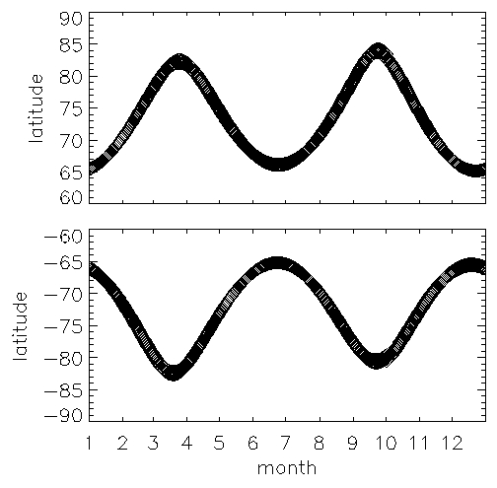 | Fig. 3. Predicted SOFIE measurement coverage for the first year on orbit. Sunrise measurements are at northern latitudes and sunset measurements are in the south.

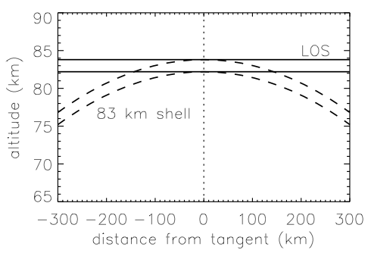 | Fig. 4. The SOFIE line-of-sight (LOS, solid) passing through an atmospheric shell at 83 km altitude with 1.5 km vertical thickness (dashed). Points where the line-of-sight enter and exit the 83 km atmospheric shell define the tangent path length of ∼290 km. This plot is not to scale.

4. Instrument Description

4.1. Optical Design
SOFIE uses a cassegrain telescope with a 10.16 cm entrance pupil. An elliptical primary mirror (16.76 × 11.55 cm) directs the incoming beam onto a focusing mirror and then to a secondary mirror (see Fig. 5). The backside of the secondary mirror contains a pickoff mirror that directs a portion of the beam into the sun sensor module. The main beam passes through a field stop that determines the instantaneous (FOV) of 2.1 arcmin vertical × 5.6 arcmin horizontal. The beam is chopped at 1000 Hz using a tuning fork device, and directed into the channel separation module (CSM) where the incoming energy is divided into the 16 spectral bands. A neutral density (ND) filter (transmission ranging from 0.398 in band 1 to 0.303 in band 16) is located at the CSM entrance to mitigate IR detector response nonlinearity by reducing optical throughput. Light terminates on the detector as an aperture image (i.e. pupil imaging system) to minimize the liability of signal drift due to coupling of solar image gradients with response gradients over the detector surface. This also insures a nearly identical matching of FOV for all detectors. The late discovery of IR detector nonlinearity required overfilling detectors 5-16 to further reduce irradiance, at the cost of slightly degrading the pupil imaging quality. This degradation resulted in a slight mismatch of weak and strong band FOVs for channels 3-8. This effect is small (less than 100 m in most cases) and corrected using the calibrated FOV response functions.
Within the CSM, energy is divided into 16 spectral bands using a combination of dichroic beam splitters and bandpass filters (Fig. 5). The CSM consists of four modules, each containing four bands that are close in wavelength. Spectral division within each CSM module is accomplished using cascading filters, which accept energy within the desired bandpass and reflect all other wavelengths to the next filter downstream. After the bandpass filter, the beam encounters a parabolic mirror which directs it onto the detector. All detectors are mounted on three-stage thermo-electric coolers (TECs) and packaged within a vented housing that contains an anti-reflective window. Bands 1 and 2 use 1 mm square photo-voltaic (PV) silicon carbide detectors and bands 3 and 4 use 1 mm diameter circular PV germanium detectors. The silicon carbide detectors have a sharp response cutoff long-ward of 0.4 μm wavelength and thus are ideally suited for the channel 1 UV measurements. The infrared (IR) bands (5-16) use 1 mm square photo-conductive (PC) HgCdTe (MCT) detectors (see Table 1). These detector types were chosen for high signal-to-noise ratio (S/N) and low implementation cost. The MCT detectors were found to have greater response nonlinearity than desired, but because SOFIE science is predominantly acquired over a signal dynamic range of 2% or less (small variations on a large solar signal) it was determined that calibration of nonlinearity in the lab and in-orbit would be more than adequate for mission objectives.

4.2. Signal Conditioning Electronics
Three measurements are accomplished for each channel, the weak and strong band radiometer signals (V_{w} and V_{s}) and the difference of these signals (ΔV). The SOFIE analog signal path from detector to digitization is illustrated in Fig. 6. Output signal from a detector preamp undergoes signal conditioning including synchronous rectification at 1000 Hz. The weak and strong band signals have adjustable attenuators which can induce gains (G_{W} and G_{S}, respectively) from 0 to 1 as commanded using a 12-bit controller. The radiometer and difference signals are digitized using a 14 bit analog to digital converter (ADC) operating from -3 to 3 V. The signals are oversampled (32 times during 50 ms) and used to determine statistical 16 bit values (91.6 μV / count) that are reported at 20 Hz (every 50 ms). Due to the sampling sequence, a given signal can be offset from the start of a 20 Hz cycle by up to 37.5 ms, and these offsets are removed during ground signal processing. The radiometer signals are digitized between 0 and 2¹⁵ counts (0 to 3V) providing a granularity in measured transmission of 3.05 × 10⁻⁵. The ΔV measurements operate from -2¹⁵ to 2¹⁵ counts providing a transmission grannularity ranging from 1.02 × 10⁻⁶ for G_{ΔV} = 30 to 1.02 × 10⁻⁷ for G_{ΔV} = 300.
The ΔV signals are balanced in orbit to a desired exoatmospheric value, ΔV_{bal}, using the strong and/or weak band attenuators. ΔV_{bal} is set before the sun is encountered based on measurements from previous events. The value of ΔV_{bal} is flexible, with the greatest dynamic range realized for ΔV_{bal} = -3V. The ΔV balance precision is a function of the balance attenuator step size and the ΔV gain. The 12-bit attenuators give ΔV balance precision ranging from 120 counts for G_{ΔV} = 30 and 1200 counts for G_{ΔV} = 300. In ground processing G_{ΔV} is removed from the ΔV measurements which are then mathematically adjusted to be consistent with ΔV_{bal} = 0. Thus, a precise ΔV balance condition in-orbit is not critical.

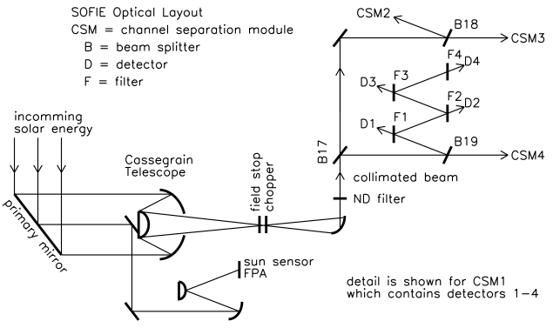
Fig. 5. SOFIE optical system block diagram, showing the location of beam splitters, mirrors, and the four CSMs. Detail shown for CSM 1 includes the detectors and cascading filters.

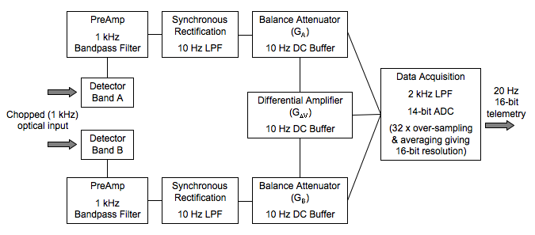
Fig. 6. Electrical block diagram for a pair of SOFIE detectors comprising a single channel. The two paths represent the strong and weak band signal chains (LPF denotes low pass filter and ADC denotes analog to digital converter).

4.3. Sun Sensor
The SOFIE instrument contains a sun sensor used to determine the angular location of the solar image relative to the science FOV. Given orbital ephemeris information and FOV location relative to the sun, tangent altitude can be accurately determined, and tangent altitude spacing between measurement samples can be determined with extreme accuracy. SOFIE pointing is controlled by the spacecraft, and spacecraft pointing offsets are refined using sun sensor information. Solar image location is important because intensity varies across the solar disk and movement of the FOV can change the underlying source intensity (V₀), which must be known to infer atmospheric transmission. Given knowledge of the solar intensity distribution from exoatmospheric solar scans (which are in terms of sun sensor angles), the exact FOV location is unimportant if relative movement of the FOV on the solar disc can be determined precisely. Thus, SOFIE requires pointing knowledge precision rather than absolute accuracy.
The sun sensor intercepts a portion of the incoming solar beam immediately after the primary mirror (Fig. 5). This beam is directed through a neutral density filter to reduce intensity and a spectral bandpass filter with a center wavelength of 701.4 nm and 23 nm width. The sun is imaged onto a radiation hardened CMOS focal plane array (FPA) comprised of 1024 x1024 pixels. FPA signals are acquired in rectangular sub-regions and pixel intensities are digitized using a 10-bit converter. The sun sensor FPA field of view of 2.04° in azimuth and 2.025° in elevation easily encompasses the 0.5° diameter solar image (Fig. 7). Individual FPA pixels have 15 μm pitch which subtends ~7.10 arcsec in azimuth and ~7.18 arcsec in elevation at the center of the array. The effective pixel resolution is about 17 arc seconds due to light dispersion by the sun sensor optics. This blur actually increases the precision in determining movement of the solar image edge on the FPA. The intensity distribution from model calculations across the solar image at the sun sensor wavelength is shown in Fig. 8.
The sun sensor tracks solar position and movement by first locating the solar image on the FPA using a 2-D center of mass algorithm, then tracking the sun by detecting the solar top, bottom, left, and right edges. The edge detection routine uses a small region of interest (ROI) at each of the four edges, which are 15 pixels across the edge by 21 pixels parallel to the edge (Fig. 8). Each row of pixels in the top and bottom ROI are averaged (i.e. parallel to the edge) to produce an average pixel intensity profile across the edge. The edge is defined by the position of a relative intensity value, I_{E}, nominally 25% of the brightest pixel average, and located in the on-board algorithm using linear interpolation on the two points surrounding I_{E}. Using pixel intensity averaging and linear interpolation reduces measurement noise and allows for rejection of erroneous results. Laboratory calibration indicated that the solar image edge location is determined with better than 0.7 arcsec precision in azimuth and elevation. This result confirms theoretical predictions of the sun sensor performance capabilities which suggested a precision of less than 1 arcsec. The row sums are recorded and included in the telemetry stream. Initial results using enhanced edge modeling in ground processing have shown a precision of 0.2 arcsec or better. Ground analysis is expected to reduce the edge detection precision to under 0.1 arc seconds. Sun sensor data are reported at 20 Hz.

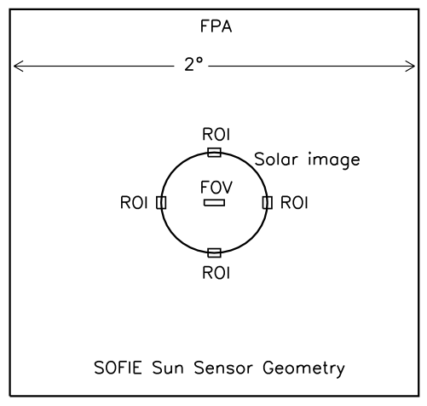 | Fig. 7. Dimensions of the SOFIE sun sensor focal plane array (FPA), solar image, and science FOV. Pixel regions of interest (ROIs) used to determine four solar edge locations are also shown. All dimensions are to scale, except the ROIs which are magnified by 50% for clarity.

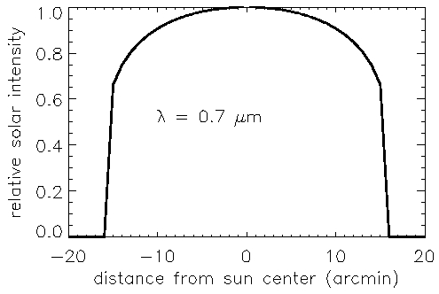 | Fig. 8. Modeled angular distribution of relative solar intensity at the sun sensor wavelength of 0.7 μm.

5. Instrument Calibration and Performance
SOFIE was calibrated in the laboratory under vacuum at the predicted nominal operational temperature (-20°C), and at the predicted cold (-35°C) and hot (5°C) operational temperature limits. Temperature measurements on orbit show mean CSM temperatures of roughly -16°C with variations of about 0.5 to 1°C over the course of an orbit, well within the range of ground calibration temperatures. Radiative calibration sources included a solar emulator blackbody (SEB) which achieved temperatures up to ∼3000K. Radiance from the SEB was equivalent to 28 to 46% of the exoatmospheric solar signal in bands 5 - 16. The SEB provided about 0.1% of the expected exoatmospheric solar signal in bands 1 and 2, and 8% for bands 3 and 4. Bands 1-4 were therefore stimulated with alternate sources including a xenon lamp. The Sun was viewed in the laboratory by directing the solar image into the SOFIE aperture using external pointing mirrors. Atmospheric transmissions on a cloud-free day ranged from zero in bands 1, 6, 7, and 13 to 0.99 in bands 3 and 4. A benefit of the CSM ND filter was realized during calibration because irradiance from the SEB in bands 5-16 without the ND filter was equivalent to full-sun radiance levels expected on-orbit with the ND filter installed, allowing calibration over the full dynamic range. While this section primarily covers ground calibration results, on-orbit results are discussed in some cases.

5.1. Noise and Background
Radiometer background signals were characterized in the laboratory using measurements with the aperture cover closed. These results show background levels ranging from 11 to 20 counts. In-orbit measurements taken prior to opening the aperture cover show background levels that are nearly identical to the laboratory results (see Table 2). System noise levels for the radiometers (η_{V}) and difference signals (η_{ΔV}) were characterized using measurements with the aperture closed, and while viewing a radiative source. Because the effective bandpass of the data is ~2 Hz (see section 3), noise is defined as the response standard deviation of the mean determined at 0.5 second intervals from the 20 Hz measurements. For truly random noise below the digitization limit, the expected η_{V} for randomly varying signals is 0.29 counts. The radiometer noise determined in the laboratory while viewing the SEB is on the order of 0.2 counts, indicating that the true radiometer noise level is below the digitization limit. In-orbit sun center measurements from over 100 days in 2007 confirm the laboratory results, indicating noise values from 0.13 to 0.2 counts (see Table 2). True radiometer signal-to-noise ratios (S/N = V/η_{V}) are therefore in excess of ~1.6 × 10⁵.
While the radiometer measurements (V) do not resolve the detector noise, the ΔV noise is resolved because the signals are electronically amplified by a gain, G_{ΔV}, of 30 to 300 prior to digitization. The ΔV S/N, defined as G_{ΔV} V₀ /η_{ΔV}, was also determined from laboratory and in-orbit measurements with the aperture cover closed. The results indicate similar performance pre and post-launch (Table 2), with S/N ranging from 2.7 × 10⁵ in channel 8 to over 40 × 10⁵ in channel 2. While this provides an estimate of the system dark noise and confirm that no significant post-launch changes occurred, it does not characterize true performance when fully illuminated. Therefore, the ΔV S/N was assessed using in-orbit sun center measurements from over 100 days in 2007. These results indicate S/N ranging from 1.9 × 10⁵ in channel 8 to 27 × 10⁵ in channel 2. While slightly lower than the cover-closed measurements, the sun center ΔV S/N values are at or in excess of requirements.

Table 2. Calibration Results.
Chan | Band / Target¹ | Back-ground²,  ground / orbit (counts) | ΔV S/N², ground / orbit (×10⁵) | V noise³, orbit (counts) | FOV FWHM⁴ (arcmin)  vertical / horizontal | Out-of-Band Energy (%) | Nonlinearity (%) ± uncertainty (%) | Nonlinearity Constant, K (10⁻⁶ counts⁻¹) ±uncertainty (%)
1 | 1 / O₃ s | 15.5 / 16.4 | 21 / 19 | 0.14 | 2.08 / 5.08 | 1.62 | 0 | 0
1 | 2 / O₃ w | 12.4 / 13.2 | 21 / 19 | 0.18 | 2.15 / 5.43 | 0.11 | 0 | 0
2 | 3 / PMC s | 15.9 / 15.7 | 59 / 49 | 0.13 | 2.05 / 5.90 | 2.67 | 0 | 0
2 | 4 / PMC w | 13.4 / 13.6 | 59 / 49 | 0.13 | 2.04 / 5.90 | 1.33 | 0 | 0
3 | 5 / H₂O w | 17.4 / 17.6 | 4.2 / 3.6 | 0.16 | 1.99 / 4.54 | 1.14 | 6.3 ± 0.3 | 1.79 ± 5.4
3 | 6 / H₂O s | 16.3 / 16.6 | 4.2 / 3.6 | 0.14 | 2.03 / 5.37 | 0.91 | 5.8 ± 0.3 | 1.56 ± 5.8
4 | 7 / CO₂ s | 17.7 / 17.5 | 3.9 / 3.9 | 0.14 | 2.14 / 5.20 | 0.26 | 30.9 ± 0.2 | 9.58 ± 0.7
4 | 8 / CO₂ w | 16.4 / 16.2 | 3.9 / 3.9 | 0.20 | 2.10 / 6.17 | 0.66 | 29.7 ± 0.4 | 8.55 ± 1.3
5 | 9 / PMC s | 19.2 / 19.3 | 3.0 / 2.5 | 0.19 | 2.03 / 4.15 | 0.24 | 2.9 ± 0.2 | 0.80 ± 8.2
5 | 10 / PMC w | 18.9 / 19.3 | 3.0 / 2.5 | 0.13 | 1.88 / 5.76 | 0.16 | 6.5 ± 0.2 | 1.60 ± 4.5
6 | 11 / CH₄ s | 19.2 / 18.5 | 5.2 / 6.8 | 0.12 | 2.32 / 6.04 | 0.34 | 6.7 ± 0.2 | 1.74 ± 3.6
6 | 12 / CH₄ w | 18.6 / 18.8 | 5.2 / 6.8 | 0.13 | 1.90 / 6.00 | 0.29 | 8.0 ± 0.2 | 2.56 ± 2.8
7 | 13 / CO₂ s | 14.9 / 13.4 | 6.0 / 6.0 | 0.15 | 2.15 / 6.36 | 0.03 | 17.7 ± 0.4 | 5.01 ± 2.2
7 | 14 / CO₂ w | 15.6 / 15.2 | 6.0 / 6.0 | 0.11 | 2.25 / 6.17 | 0.23 | 11.4 ± 0.3 | 3.15 ± 2.7
8 | 15 / NO w | 11.6 / 11.4 | 2.7 / 2.7 | 0.12 | 2.17 / 5.97 | 0.17 | 7.1 ± 0.2 | 1.93 ± 2.8
8 | 16 / NO s | 15.4 / 13.6 | 2.7 / 2.7 | 0.18 | 2.14 / 5.26 | 0.16 | 7.8 ± 0.2 | 2.20 ± 2.7
¹s indicates strongly absorbing band, w denotes weakly absorbing band.
²determined from aperture closed measurements
³determined from sunrise sun center measurements at 145-155 km altitude from May 23 – September 15, 2007
⁴FOV full width half maximum (FWHM) is the separation between half-power points.

5.2. Response Linearity
The PC MCT detectors in bands 5-16 exhibit response nonlinearity ranging from 2 to 30% at radiance levels consistent with an exoatmospheric solar view. The response of a nonlinear system (V_{M}) can be defined as the product of the linear response (V_{L}) and a nonlinear term (f), V_{M} = V_{L} f(V_{M}). SOFIE nonlinearity was calibrated by stimulating the instrument over it’s dynamic range with the SEB while cycling a CaF₂ window (transmission τ_{W} ≈ 0.93) through the beam to induce a small signal change of known magnitude. The measured window transmission (τ_{M}) as a function of V_{M} contains the effects of response nonlinearity and is the basis for characterizing the nonlinear term. Hervig et al. (2007) discuss the calibration of IR detector nonlinearity, and determined that the nonlinear term can be described by
f(V_{M}) = 1 - KV_{M} (10)
where K is a constant. This expression produces a linear relationship between τ_{M} and V_{M}, over useful measurement ranges, consistent with observed performance during SOFIE calibration. Calibrations using the SEB were completed prior to installation of the CSM ND filter to obtain radiance levels consistent with an in-orbit exoatmospheric solar view and the ND filter installed. An example of the measured CaF₂ window transmission versus response is shown in Fig. 9, where a linear fit to τ_{M} versus V_{M} is overlaid. Results as in Fig. 9 were used to analytically determine K, as described by Hervig et al. (2007). The calibration results are summarized in Table 2, where nonlinearity is defined as 100[1 - f(V₀)] (%) using in-orbit measurements of V₀. Calibrations completed with the ND filter installed offered less dynamic range, but confirmed the results in Table 2. Because the calibration results describe nonlinearity in terms of the measured response, application of the calibration must account for differences in the balance attenuator setting for a given measurement (G) and for the calibration configuration (G_{cal}).
f(V_{M}) = 1 – K V_{M} G_{cal} / G (11)
In all calibration results presented here G_{cal} was set to 0.83.

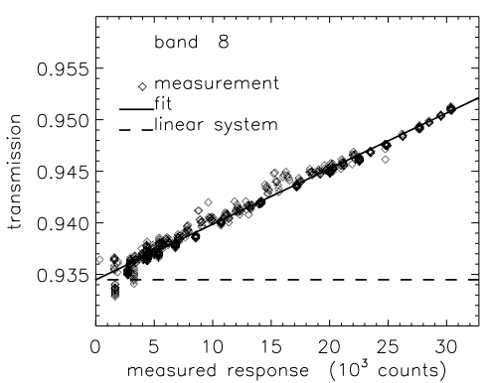 | Fig. 9. Nonlinearity calibration results for band 8. The data were obtained without the flight ND filter installed using the SEB for stimulus. a) Measured filter transmission versus response and a linear fit to these data, consistent with the description of nonlinearity in (10). The transmission measured by an ideal linear system is also shown.

5.3. Field of View
The FOV response functions were calibrated using several procedures. The first was by scanning a point source image across the SOFIE FOV using a precise steering mirror. The FOV widths were defined as the distance between half-power points and the boresight center is defined as the integrated centroid. Horizontal (vertical) averages of point source response data were used to determine vertical (horizontal) FOV response functions. FOV functions determined from point source data at cold, nominal, and hot science temperatures indicate no temperature dependence to either the FOV width or position. An example of vertical FOV response derived from the point source measurements is shown in Fig. 10a for channel 6 (bands 11 and 12). Fig. 10b shows the FOV mismatch for channel 6, determined as the difference of the FOV functions after they are normalized to equal area. The FOV mismatch is important for interpreting ∆V signals when scanning across spatially abrupt features such as the solar edge or cloud layers. Mismatch is explicitly incorporated in the forward signal simulations during data processing. The vertical FOV widths and boresight locations are shown in Fig. 11 for each band. Table 2 summarizes characteristics of the SOFIE FOV determined from the point source measurements for bands 3-16 and the UV knife edge tests for bands 1-2. The average FOV dimensions for all bands are 2.09 ± 0.11 arcmin in elevation and 5.58 ± 0.62 arcmin in azimuth, which corresponds to 1.60 ± 0.08 km in elevation and 4.28 ± 0.48 km in azimuth at the 83 km tangent point. The point source results were confirmed using knife edge tests where an effective far-field rectangular image of source radiation was scanned vertically and horizontally across the SOFIE FOV using a precision steering mirror. Off-axis rejection characterized by slowly shuttering a far field source revealed insignificant light contamination outside of the FOV dimensions determined from the point source calibrations.

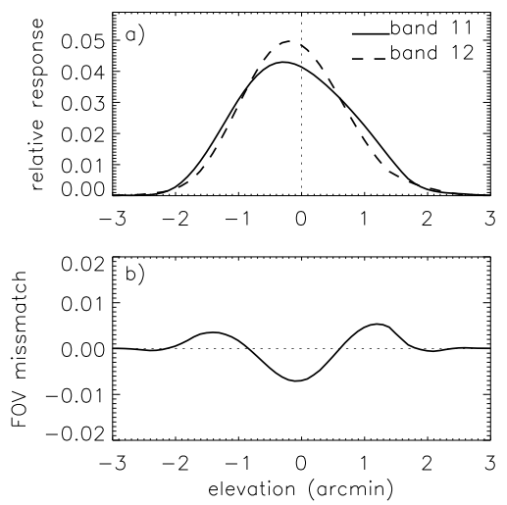 | Fig. 10. a) Vertical FOV relative response functions for bands 11 and 12 (channel 6). b) The band pair FOV mismatch function, determined as the difference of the FOV response curves.

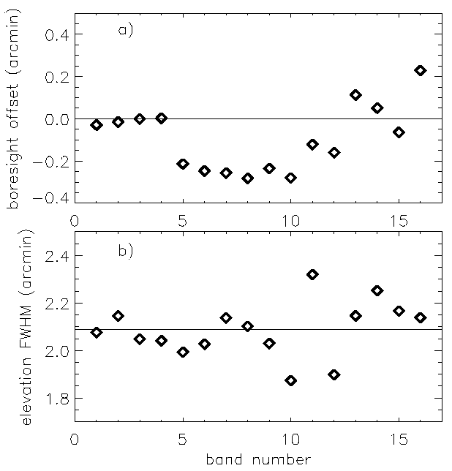 | Fig. 11. a) FOV elevation boresight location of each band relative to band 3. b) the FOV width (full-width half-maximum) in elevation for each band. The mean for all bands is indicated by a horizontal line.

5.4. Spectral Response.
End-to-end relative spectral response (RSR) was characterized using a step-scan Fourier Transform Spectrometer (FTS). The output beam from the interferometer was observed by SOFIE, making the SOFIE output the RSR interferograms. Because this beam did not fill the SOFIE aperture, multiple measurements were performed at slightly different input positions with negligible change in RSR results. RSR curves for bands 1-16 at nominal temperature are shown in Fig. 12. Calibration included the in-band and out-of-band RSR at -35, -20, and 5°C. The temperature dependence in bandpass position and width (full width half maximum, FWHM) are shown in Fig. 13 as the measured change per °C. The changes in band center and FWHM are generally smaller than about 0.1 cm⁻¹ °C⁻¹. The exception is band 1 where the center and FWHM change by about 1 cm⁻¹ °C⁻¹. However, the band center shift and FWHM change are only about 0.08% of the 1332 cm⁻¹ band 1 bandwidth. In bands 2-16, the band center shift is less than 0.01% of the FWHM and the FWHM change is less than 0.05% of the FWHM. Temperature dependence in the SOFIE RSR is handled in the foreword model by capturing the temperature dependence of the upper and lower half power points and adjusting the RSR position and width accordingly. Out-of-band (OOB) spectral response was characterized over the wavelength limits of the detector response. The total energy contribution (I_{T}) was determined by integrating the solar spectrum (Kurucz, 1995) over the complete RSR curve (in-band and OOB). The relative in-band energy (I_{B}) was determined for wavelengths within ± 1.5 FWHM of band center. The relative OOB energy, defined as 100(I_{T} - I_{B})/I_{B} (%), is less than 3% in all cases (Table 2). The OOB portion of the RSR is included in the forward model spectral integrals when needed, as determined from simulations.
The sun sensor RSR was derived using component-level measurements of the flight spare ND filter and bandpass filter, and manufacturer measurements of the FPA RSR. The primary sun sensor function of solar tracking does not require stringent RSR calibration. Secondary functions including stratospheric O₃ retrievals do require RSR knowledge.

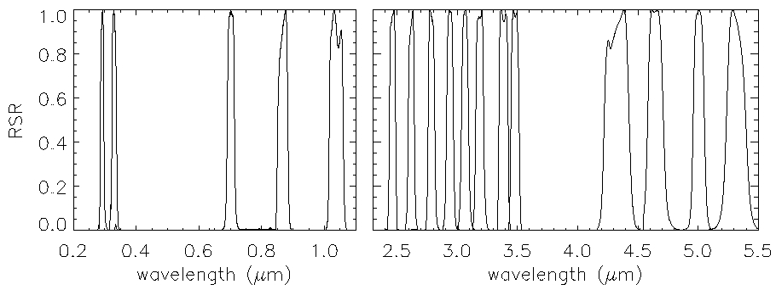
Fig. 12. Relative spectral response for bands 1-16 measured at -20°C and for the sun sensor (0.7 μm).

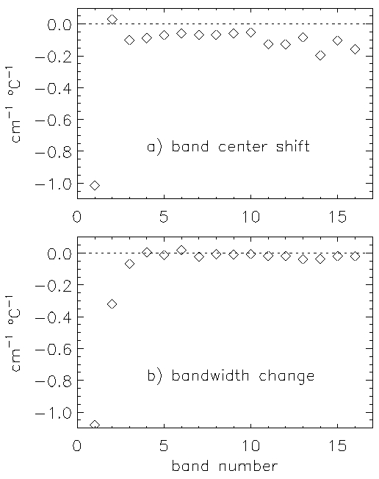 | Fig. 13. Temperature sensitivity of a) band center location and b) bandwidth, shown as the change per °C for bands 1-16.

5.5. Time Response
The time response of the radiometer signals was determined from component modeling, and validated by inducing a rapid signal change. This was accomplished by illuminating the aperture and either rapidly moving the incoming beam or quickly shuttering the beam. The time response for each band was as expected, within the test uncertainty.

5.6. Sun Sensor
Solar tracking performance was tested in the laboratory by monitoring the solar image directed into the SOFIE aperture using external tracking mirrors. Tracking precision, defined as the 2 Hz standard deviation of mean solar position averaged over 0.5 seconds was determined to be 0.70 arcsec in elevation and 0.54 arcsec in azimuth. Due to scintillation effects in the lower atmosphere during ground testing, this performance was expected to improve in-orbit. The in-orbit precision has now been verified to be less than 0.2 arcsec in azimuth and elevation.

6. In-orbit Calibration
Solar Source Function. Solar scans are performed with each event to characterize the spatial dependence of solar intensity (i.e., solar limb darkening curve (SLDC)) in each bandpass. The SLDCs are used in data processing to correct signal changes resulting from unwanted movement of the FOV, and to account for changes in the solar source due to refraction of the solar image observed at tangent altitudes below about 50 km. Because solar intensity decreases away from sun center, FOV drift will result in a decrease in measured intensity that would be falsely attributed to the atmosphere if not modeled. The signal model includes integration of the FOV over the SLDC. To characterize the SLDC for each event, the exoatmospheric solar disc is scanned from the bottom to the nominal FOV location and then over a 1 arcmin box encompassing that location. Because spacecraft pointing stability is typically better than 10 arcsec during an occultation, FOV movements are small compared to the FOV dimensions. The measured source function is therefore smooth on the scale of the pointing movement, making the correction for pointing-induced signals very accurate.
Boresight. The science FOV alignment relative to the sun sensor is determined in-orbit by scanning the FOV over the solar image and determining the location on the sun sensor FPA which corresponds to the science signal boresight. The image center location is estimated by calculating the midpoints between edge locations from the sun sensor data (e.g., Fig. 7). The relative alignment is consistent with results from ground calibration, and appear to be stable.
ΔV Gain. Because the uncertanty in absorption determined using the difference signal measurements is directly proportional to the uncertainty in ΔV gain, G_{ΔV} is periodically verified in-orbit. This is accomplished by changing the weak band attenuator, G_{W}, between two settings while viewing the sun above the atmosphere to induce a change in V_{W} (δV_{W}) and ΔV (δΔV). The measured changes yield the value of G_{ΔV}:
G_{ΔV} = δΔV / δV_{W} (12)
Because V_{W} , V_{S} and ΔV are all measured with the same ADC for a given channel, results are identical if V_{S} is used. The method is used routinely in-orbit to calibrate G_{ΔV} with less than 1% uncertainty. Initial in-orbit results indicate these gains are stable and unchanged since ground calibration.
Non-Linearity. Response nonlinearity can be calibrated in orbit using concepts described in section 5.2. For the in-orbit approach, atmospheric transmission profiles are measured with the FOV at the center of the sun, and on alternating events with the FOV near the edge of the sun where solar intensity is lower (e.g., Fig 8). The effects of nonlinearity will vary with solar intenstiy, yielding differences in the measured transmision profiles. In the absence of atmospheric variability, transmission profiles obtained using different solar intensity should be identical after nonlinearity is corrected. Differences in the transmission profiles are used to adjust the nonlinearity constant K, and a statistical set of profiles is used to eliminate atmospheric variation as a significant error. Measurements collected for nonlinearity calibration have not been analyzed as of this writing.

7. Data Processing / Measurement Inversion
The following is a brief review of approaches used in the level 1 and level 2 processing. Technical data included in the SOFIE Algorithm Theoretical Basis Document (ATBD) is available on the SOFIE website.

7.1. Level 1
Level 1 processing registers all data with absolute times and zenith angles. Ephemeris information is used to determine the SOFIE FOV line of sight position versus time in Earth coordinates. SOFIE detector and sun sensor data are put on a uniform 200 m altitude grid for ease of use.
Solar Limb Darkening Curves. Solar limb darkening curves are measured using exoatmospheric solar scans as described above. These data are used to generate partial two dimensional maps of solar intensity in sun sensor coordinates sufficient for use in level 2 processing when spatially integrating simulated transmissions over the FOV and solar source.
Auxiliary data. Independent temperature/pressure profiles from National Center for Environmental Prediction (NCEP) analyses are used in the registration of SOFIE profiles in absolute altitude. For this purpose, data are taken from the NCEP grid point closest to the location and time of a SOFIE measurement. Thermospheric temperatures required in signal simulations above the upper limit of SOFIE temperature retrievals (about 105 km) are taken from the MSIS 2000 model [Hedin, 1991]. MSIS is initialized using current solar flux information from the National Oceanic and Atmospheric Administration.
Signal conditioning. Time offsets due to the multiplexer sampling (from 0 to 0.0375 s) and electronic filtering (0.1 s) are removed from all radiometer and difference signals. Background signals are subtracted from the radiometer signals. Electronic gain is removed from the difference signals through division by the known G_{ΔV}. To simplify their use in level 2 processing, a balance correction is applied to the ΔV, V_{W}, and V_{S} signals so that the data is equivalent to an exoatmospheric condition of ΔV = 0 and V_{W0} = V_{S0}.
SOFIE signals can change slowly during an event for a variety of reasons, including thermal changes within the CSM optics and FOV movement on the solar image. Signal drift caused by FOV movement is removed explicitly by adjusting V₀ using pointing information from the sun sensor with the measured SLDC. After the pointing effects are removed, residual signal drift remains due to secondary effects such as beam movement across the detectors. The residual drift is typically small and has long time constants. It is removed by fitting it linearly in time at altitudes well above the atmosphere, and extrapolating the residual into atmospheric measurement time.
Altitude registration. SOFIE has three methods of registering transmission profiles. The current operational method uses NCEP temperature and pressure versus altitude to simulate 4.324 μm CO₂ transmission profiles. The initial SOFIE tangent point altitude profile is determined using orbital ephemeris data and FOV position knowledge. This provides the relative angle between measurements to within ± 0.2 arcsec. Altitude registration is then accomplished by adjusting the absolute position of the SOFIE altitude profile so that the measured and simulated CO₂ transmissions match at altitudes between 35 and 45 km. The second method employs an identical procedure, but uses measured refraction angle profiles determined from the sun sensor solar extent measurements, and compares them to a modeled refraction angle profile calculated ussing the NCEP T and P versus altitude. The third method, which eventually will be the final operational approach, uses temperature and pressure profiles retrieved from refraction angle measurements through the stratosphere. Absolute altitude is determined by comparing NCEP density versus altitude to the retrieved density versus relative altitude. The last two methods eliminate the use of transmission models and assumed CO₂ mixing ratios.
Refraction angle temperature retrievals. During an occultation event, solar rays are refracted by the Earth's atmosphere towards higher densities (towards Earth). Sun sensor measurements of vertical solar extent (E) are used to determine the atmospheric refraction angle versus altitude. Atmospheric refraction angles (θ) are related to solar extent by
θ_{t} = θ_{t-Δt} + (E₀ - E_{t}) (13)
where subscripts refer to time. θ_{t} is the refraction angle for a ray emanating from the bottom edge of the solar image. Δt is the time required for the un-refracted elevation angle to change by an angle equal to the un-refracted solar angular extent (E₀), which is measured above the atmosphere. The recursive process begins with measurements above the atmosphere (where θ = 0). Once the refraction angle versus time is known, the tangent point altitude corresponding to the apparent location of the sun (impact altitude, Z_{I}) can be determined from
Z_{I} = (R_{E} + Z_{SC}) cos(Φ - θ) – R_{E} (14)
where R_{E} is Earth radius, Z_{SC} is spacecraft altitude, and Φ is the angle between the spacecraft velocity vector and the spacecraft-sun vector. Altitude dependence of refraction angle is directly related to the atmospheric density profile. Therefore, assuming hydrostatic equilibrium a measured refraction angle profile can be used to retrieve temperature versus pressure. SOFIE determines refraction angles with vertical resolution of about 150 m and better than 0.2 arcsec precision. Note that equation 13, to our knowledge, has not been used before. This recursive formulation provides refraction angle profiles that depend only on the knowledge of Δt (which is accurately known from orbital ephemeris) and the observed solar extent. As a result, the need for platform attitude knowledge is effectively eliminated. The refraction angle measurement accuracy becomes equivalent to the accuracy to which the change in solar extent can be measured. Because the technique requires only knowledge of the change in E, absolute measurement errors are nearly eliminated.

7.2. Level 2
Level 2 processing retrieves the geophysical parameters of temperature, gas mixing ratios, and aerosol extinctions from the SOFIE signals. These retrievals rely on the ability to simulate SOFIE measurements. The signal simulations must first describe the radiative transfer of sunlight through the limb of the Earth’s atmosphere, and second account for instrumental effects. Atmospheric transmissions are simulated using rigorous line-by-line radiative transfer calculations (Gordley et al., 1994) with appropriate gaseous line parameters. The radiative transfer calculations assume a spherically symmetric atmosphere.
The simulated transmissions are convolved spatially over the SOFIE FOV response and the measured solar source function, and spectrally over the instrument RSR curve and relative solar spectrum (Kurucz, 1995). The simulated band and source averaged transmissions are then converted to counts based on the measured exoatmospheric signals, and nonlinearity is applied to the simulated V and ΔV signals based on the coefficients in Table 2. For the ΔV signals, the weak and strong band signals are modeled as above, and ΔV is determined from the simulated V_{W} and V_{S}. Simulated signals are compared to the measurement, and the target gas mixing ratio, Q, is adjusted based on the derivative δτ/δQ, which considers the previous attempt to match the measurement. Iteration continues at a given altitude until the measured signal is reproduced to within the noise. The retrievals assume an isothermal and evenly mixed upper boundary. This has a minor impact on results due to the extremely weak extinction at altitudes above the start of retrieval. The exceptional fidelity and S/N of the data allows a direct “onion peel” retrieval on the 200 m vertical grid defined in level1 processing. However, operationally each profile is separated into seven individual profiles at 1.4 km spacing which are processed independently. The resulting seven profiles are combined and smoothed with a 0.8 km full width Gaussian to remove possible digitization error, and final retrieval products are reported on the uniform 200 m vertical grid. Table 3 gives important characteristics of the SOFIE retrievals.
Table 3. SOFIE retrieval characteristics.
Retrieval | Measurements Used (Intended*) | Altitude Range (Intended*) | Precision at  83 km (unless otherwise noted) | Comment
T | band 13  (channels 4 and 7) | 50 – 105  (15 – 110) | 0.1 K | >7 K warm bias due to non-LTE above 80 km, this is understood and being addressed
T | 701 nm wavelength refraction angle | 0 – 50 | 0.5 K (30 km)
O₃ | band 1 (channel 1) | 50 – 100 | 3 ppbv
H₂O | band 6 (channel 3) | 50 – 95  (15 – 105) | 21 ppbv
CO₂ | (channels 4 and 7) | (15 – 95) | - | Not retrieved as of this writing.
CH₄ | band 11 (channel 6) | 50 – 79  (15 – 90) | 13 ppbv (80 km)
NO | (channel 8) | (80 – 110) | - | Not retrieved as of this writing.
PMC extinction (radiometers) | bands 3, 4, 5, 8, 9, 10, 12, and 14  (bands 2 and 15) | cloud | 2×10⁻⁸ km⁻¹
PMC extinction (difference signals) | channel 2  (channel 5) | cloud | 6×10⁻¹⁰ km⁻¹
*the planned evolution of SOFIE data analysis

Temperature/CO₂ Retrievals. SOFIE retrieves temperature/pressure and CO₂ mixing ratios simultaneously using measurements from channels 4 and 7. The approach assumes hydrostatic equilibrium and works from low to high altitude. Because of the high degree of in-orbit inter-calibration of channels required for accurate CO₂ retrievals, CO₂ is not included in the first release of SOFIE data. CO₂ mixing ratios from the WACCM model, which is based on the CAM3 model (Collins et al. 2003), are used to retrieve temperature and pressure for the first release. Future releases are planned to include retrieved CO₂ above 60 km.
Optical Cross Sections. Except for O₃ and molecular (Rayleigh) scattering, all gas molecules are modeled using line parameters from the HITRAN (2006) data base. Rayleigh scattering, an important contribution in bands 1-4, is modeled using the expression of Bodhaine et al. (1999), and combined with molecular densities calculated using SOFIE temperature profiles to determine molecular extinction. Ozone transmission is modeled using the HITRAN 2004 cross sections which cover temperatures from 200 to 300 K. In band 1, the O₃ cross sections vary (approximately linearly) by less than 10% between 200 and 300 K. Linear extrapolation to summer mesosphere temperatures (150 K) suggests less than 5% changes from the 200 K cross sections. Because the change in cross section is apparently small, and the temperature extrapolation is uncertain, the current algorithm interpolates for temperatures between 200 and 300 K but does not attempt to extrapolate in temperature. In band 2, the O₃ cross sections change by 10 to over 100% from 200 to 300 K, varying with a second or third order dependence on temperature. While temperature dependence is likely a significant effect in band 2, the cross sections are more than two orders of magnitude smaller than band 1, rendering them an insignificant effect on the ozone retrievals. The treatment of low temperature O₃ cross sections will be refined in upcoming SOFIE data versions.

8. In-Orbit Performance
SOFIE was activated on 9 May 2007 after a 10 day out-gassing period. Background and noise levels characterized prior to deploying the aperture cover were nearly identical to those measured in the laboratory (see Table 2). Following a successful cover deployment, the SOFIE FOV was directed towards the sun and initial observations were taken. In-orbit bandpass filter temperatures are between -13° and -17°C, slightly warmer than the nominal case prediction (-20°C) but comfortably within design and calibration limits.
Spacecraft pointing routinely directs the SOFIE FOV to within a few arcsec of sun center, and maintains this position to within a few arcsec during an occultation. An example of pointing performance is shown in Fig. 14, where the mean solar positions measured by the SOFIE sun sensor for sunset events on 8 August 2007 are shown versus altitude. AIM pointing performance is nearly a factor of 10 better than predictions, and is an important factor in minimizing signal drifts and obtaining high signal-to-noise measurements from SOFIE.
In-orbit measurements indicate that all but band 2 are operating within the expected range of the optical-electrical system. Signals from the band 2 detector appear to be saturating the pre-amplifier electronics when viewing the center of the sun, as evidenced by solar scans where the response is as expected across the dimmer solar edges but saturating the ADC near sun center. Comparisons with band 1, which has a nearly identical SLDC, suggest that the in-orbit response of detector 2 is about 38% higher than expected based on ground calibration results, and 20% higher than the op-amp setup can accommodate. This circumstance can be mitigated by performing occultations with the FOV positioned about 13 arcmin above sun center, which reduces the solar flux at 0.330 μm wavelength by about 40%. This mode of operation is conducted periodically to obtain useful measurements from band 2, and analysis of these data indicate that the approach works well.

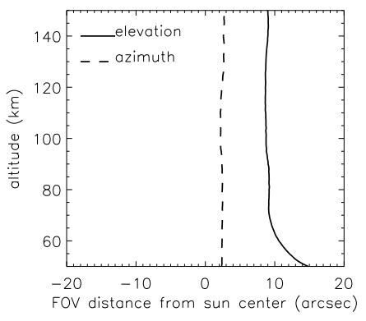 | Fig. 14. Location of solar image center in azimuth and elevation determined by the SOFIE sun sensor. The results are daily means for 15 sunset measurements on 8 August 2007. Changes in elevation below ~60 km are due to atmospheric refraction.

The only other performance anomaly is excessive sensitivity of the NO strong band (band 16) response to detector temperature. This has been traced to temperature sensitivity of the MCT detector response at wavelengths near the band 16 filter position. The oscillations occur when the sun is introduced onto the detector and last for approximately 1 minute until the TEC controller eliminates the thermal variations. The shock of solar illumination causes ~0.002 K oscillations in detector temperature which are correlated to ~0.05% oscillations in response. Because the signal oscillations are a significant fraction of expected signal due to NO they prevent accurate NO retrievals if not corrected. The signal oscillations have been removed in a few test cases, but are not currently being removed with sufficient accuracy to allow processing of the entire data set. We do not report NO retrieval results at this time, however, this effect appears to be very predictable and correctable. We expect to achieve accurate NO results for future data releases

9. Retrieval Results
SOFIE retrievals of temperature, O₃, H₂O, CH₄, and 3.064 μm extinction from the northern polar summer of 2007 are presented here. Retrievals of NO and CO₂ mixing ratio will appear in future reports. All gas and temperature retrievals are currently based on the strong band radiometer signals. The more sensitive difference signal retrievals will be implemented in upcoming data versions. The only difference signal retrievals currently conducted are using channels 2 to retrieve PMC extinction. Fig. 15 shows average profiles based on 376 SOFIE observations during July 2007 at latitudes from 66.1° to 70.5°N. Ice was identified in the SOFIE profiles according to Hervig et al. (2008, this issue), and 361 of the July observations were found to contain PMCs. In Fig. 15, average profiles for observations containing ice are compared to the average of ice-free observations. While the 15 ice-free profiles represent a small statistical set, the comparisons serve to illustrate the effects of ice contamination (or lack of) in the retrievals. The average ice layer top and bottom altitudes are also indicated in Fig 15.
SOFIE temperatures retrieved from the 4.324 μm CO₂ band are found to be more than 7 K above frost point temperatures (T_{ice}) at typical PMC altitudes on average (Fig. 15a). Because ice is detected in nearly every event and temperatures below T_{ice} are therefore expected, this result indicates a warm bias of at least 7 K in SOFIE temperatures at altitudes from roughly 80 to 90 km. The warm bias is related to non-local thermodynamic equilibrium (non-LTE) in the 4.324 μm CO₂ absorption band at altitudes above about 80 km. The non-LTE effects are currently under investigation, and preliminary results indicate that including these effects in the SOFIE temperature retrievals will remove the current warm bias. Ice extinction is generally a minor interferer in the 4.324 μm CO₂ signal, and therefore does not affect temperature, except for extremely bright clouds. This is evident in Fig. 15a where the average temperature profile for ice-free observations is nearly identical to the average for observations with ice. SOFIE H₂O retrievals based on the band 6 radiometer signals are currently conducted from 50 to 95 km altitude, and are unaffected by ice due to the extremely low ice extinction at the water band location of ~2.5 microns (Fig. 2). The July average H₂O mixing ratio is ~1 ppmv at 95 km (Fig. 15b) and steadily increases to ~7 ppmv at 80 km. The SOFIE H₂O measurement was designed specifically to be unaffected by ice contamination, as evidenced by the comparison in Fig. 15b. Upcoming retrievals will use the high-gain channel 3 difference signals which are expected to provide H₂O retrievals extending above 100 km altitude. July-average 3.064 μm extinction profiles (band 9) are shown in Fig. 15c for ice-free observations, and for observations containing ice. The ice-free observations indicate extinctions ranging from the noise (~2×10⁻⁸ km⁻¹) at 95 km to ~2×10⁻⁶ km⁻¹ at 70 km. This steady increase in extinction is due to water vapor absorption in band 9 that is from 50 to ~300 times lower than ice absorption at typical PMC altitudes. The ice observations indicate an average of ~5×10⁻⁵ km⁻¹ at the altitude of the ice extinction peak (Z_{max}, 83.2 km on average during July). For the July observations, ice was occasionally observed up to 92 km, and the average ice bottom and top altitudes were 80.0 and 86.8 km. Note that the average ice layer top altitude is located at the average mesopause height of 86.8 km.

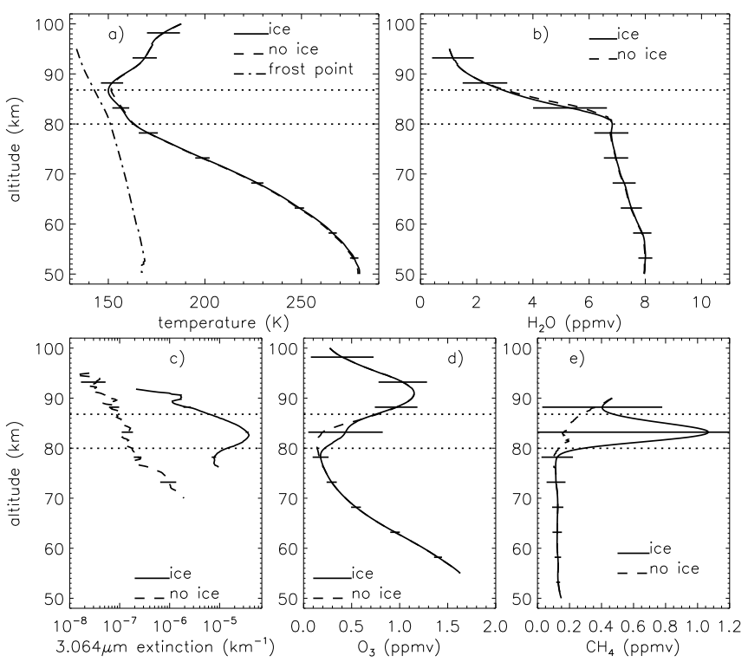
Fig. 15. Average profiles of SOFIE temperature (a), H₂O (b), and 3.064 μm extinction (c), O₃, (d), and CH₄ (e), based on 376 SOFIE observations during July 2007 at latitudes from 66.1° to 70.5°N. Average profiles are shown for only observations containing ice and for ice-free observations. Error bars indicate standard deviations for the average of observations containing ice. The average altitude of the ice layer top and bottom are indicated by horizontal dotted lines.

SOFIE ozone retrievals are based on band 1 radiometer measurements near 292 nm wavelength. O₃ absorption at this wavelength is sufficiently strong that band 1 is completely opaque at altitudes below ~50 km, depending on season and latitude. The ozone signal was anticipated to be contaminated by PMCs. Comparing the average O₃ profiles for ice-free observations and for observations that contained ice indicates a spurious increase of roughly 0.25 ppmv at Z_{max} when ice is present (Fig. 15d). Upcoming data versions will remove PMC contamination in the O₃ signals using ice extinction measurements from the dedicated PMC channels. The July average CH₄ profiles are shown in Fig. 15e. PMC contamination is evident as a spurious increase in CH₄ mixing ratio above ~79 km. While this was an anticipated limitation of the SOFIE CH₄ measurements, removal of PMC contamination will be explored. Reliable CH₄ retrievals in the presence of ice may not be a routine product, because of the extremely low CH₄ abundance at cloud altitudes and the strong ice signature in the CH₄ band.
Time versus height cross sections of SOFIE temperature, H₂O, O₃, CH₄, and 3.064 μm ice extinction for the northern summer of 2007 are shown in Fig. 16. Mesopause altitude and Z_{max} are also indicated. SOFIE temperatures depict a cold summer mesopause near ~87 km where temperatures are about 150 K. Water vapor is observed to increase steadily over time at altitudes below the mesopause, consistent with upwelling in the summer mesosphere which transports H₂O from lower altitudes. The abrupt decrease in H₂O above Z_{max} is consistent with a loss of water vapor to ice growth, and from destruction of H₂O by increasing photolysis at higher altitudes. Ice is observed at altitudes from roughly 80 km to just above the mesopause. The presence of ice is coincident with the duration of cold temperatures near the mesopause. The mesospheric ozone minimum is observed near 79 km altitude, with a peak observed near 90 km. O₃ enhancement is observed at altitudes from roughly 80 to 95 km during times that ice is present. For example, at 92 km the mixing ratio increases from 0.8 ppmv on 22 May (30 days before solstice) to ~1.1 ppmv by 11 July, returning to ~0.8 ppmv by 15 August. Siskind et al. (2007) discuss the increase in O₃ above PMCs and determined that the change was consistent with dehydration above the ice layer resulting in lowered HO_{x}. CH₄ is observed to increase over time, consistent with transport from below due to upwelling in the summer mesosphere. At 78 km CH₄ increases from ~25 ppbv on 22 May to ~over 100 ppmv by 21 June, with variations between 60 and 150 ppmv for the remainder of summer.
An example refraction angle temperature retrieval is shown in Fig. 17 where SOFIE is compared to a coincident temperature profile from the National center for Environmental Protection (NCEP). The agreement between SOFIE and NCEP is very good at altitudes below 45 km. This retrieval used results from the on-board sun sensor algorithm. Ground processing is expected to extend accurate temperature retrievals to well above 50 km. The refraction angle temperature retrievals will eventually be merged with CO₂ channel results to create a temperature product that extends from near the surface to over 100 km.

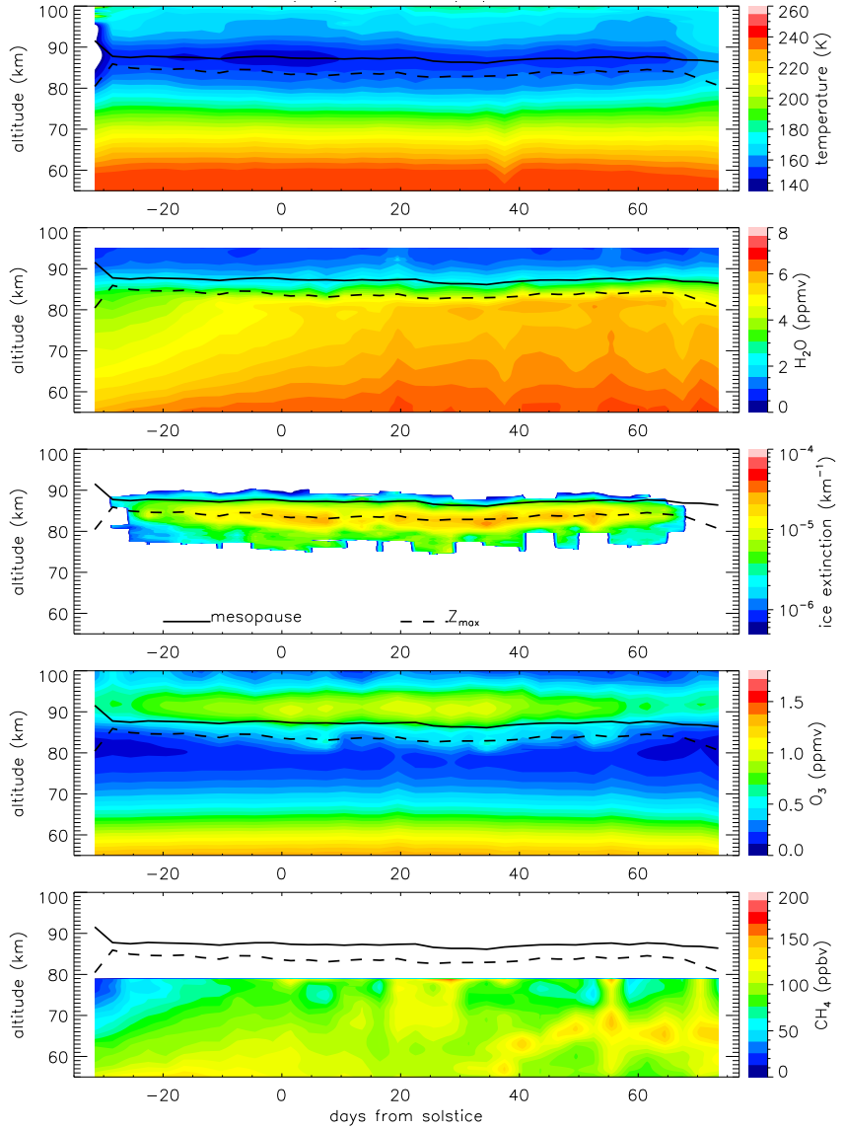
Fig. 16. Time versus height cross sections of SOFIE T, H₂O, 3.064 μm ice extinction, O₃, and CH₄, constructed from 3-day averages. Average mesopause height and ice extinction peak altitude are overlain (as labeled in center plot).

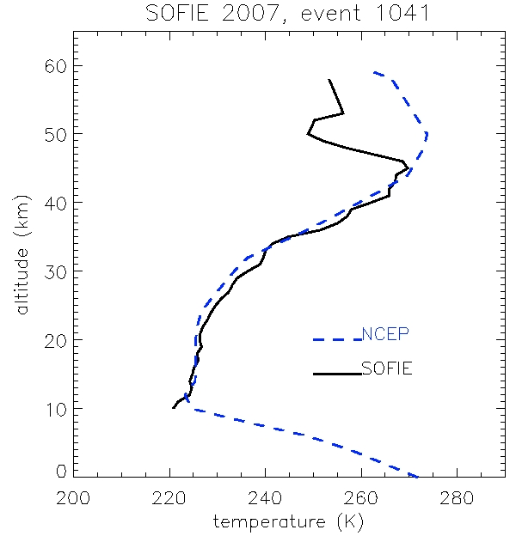 | Fig. 17. Temperature profile retrieved from SOFIE refraction angle measurements on July 4, 2007, 16:04 UT, at 66.3°N, 104.3°E, compared to coincident NCEP temperatures.

10. Summary
SOFIE has successfully conducted solar occultation measurements from the AIM observatory since May 2007 and continues operation as of this writing. SOFIE measurements are currently used to retrieve vertical profiles of temperature, O₃, H₂O, CH₄, and ice extinction at multiple wavelengths. Upcoming efforts will produce CO₂ and NO mixing ratio retrievals, and incorporate the high-gain difference signal measurements to yield even greater precision. The current results from T, H₂O, O₃, CH₄, and ice extinction retrievals indicate excellent measurement performance. A description of the SOFIE experiment and data from the initial public release are available online at aim.hamptonu.edu.

Acknowledgements. The AIM mission is funded by NASA’s Small Explorer program. SOFIE was built by the Space Dynamics Laboratory (SDL) at Utah State University in Logan, Utah. Many thanks to the SOFIE team at SDL for tireless dedication over many years and through many trials. Thanks to Orbital Sciences who’s efforts to provide a high precision pointing system were critical to SOFIE success. Thanks to the AIM team members for contributions and support during the past years.

11. References
Bodhaine, B.A., N.B. Wood, E.G. Dutton, & J.R. Slusser, "On Rayleigh Optical Depth Calculations", J. Atmos. Ocean. Tech., 16, 1854-1861, 1999.
Collins, W. D., P. J. Rasch, B. A. Boville, J. J. Hack, J. M. McCaa, D. L. Williamson, B. Briegleb, C. M. Bitz, S. -J. Lin, and M. Zhang, The formulation and atmospheric simulation of the Community Atmosphere Model: CAM3, J. Climate, in press, 2006.
DeLand, M. T., E. P. Shettle, G. E. Thomas, and J. J. Olivero, Solar backscattered ultraviolet (SBUV) observations of polar mesospheric clouds (PMCs) over two solar cycles, J. Geophys. Res., 108(D8), 8445, doi:10.1029/2002JD002398, 2003.
Gordley, L. L., B. T. Marshall, and D. A. Chu, LINEPAK: Algorithms for modeling spectral transmittance and Radiance, JQSRT, 52, p563, 1994.
Hedin, A. E., Extension of the MSIS thermosphere model into the middle and lower atmosphere, J. Geophys. Res., 96 (A2), 1159, 1991
Hervig, M. E., R. E. Thompson, M. McHugh, L. L. Gordley, J. M. Russell III, and M. E. Summers, First confirmation that water ice is the primary component of polar mesospheric clouds, Geophys. Res. Letters, 28, 971-974, 2001.
Hervig, M., M. McHugh, and M. Summers, Water vapor enhancement in the polar summer mesosphere and its relationship to polar mesospheric clouds, Geophys. Res. Letters, 30(20), 2041, doi:10.1029/2003GL018089, 2003.
Hervig, M., and D. Siskind, Decadal and inter-hemispheric variability in polar mesospheric clouds, water vapor, and temperature, J. Atmos. Solar-Terr. Phys., doi:10.1016/j.jastp.2005.08.010, 2006.
Hervig, M., L. Gordley, M. McHugh, E. Thompson, B. Magill, and L. Deaver, On-orbit calibration of HALOE detector linearity, Appl. Opt., 46, 7811-7816, 2007.
Kurucz, R.L., “The solar spectrum: atlases and line identifications, Laboratory and Astronomical High Resolution Spectra,” in Proceedings of Astron. Soc. of the Pacific Conf. Series 81, A.J. Sauval, R. Blomme, and N. Grevesse, eds., pp. 17-31, 1995.
Lübken, F.-J., Thermal structure of the Arctic summer mesosphere, J. Geophys. Res., 104 (D8), 9135, 1999.
Russell, J. M. III, S. M. Bailey, M. Horányi, L. L. Gordley, D. W. Rusch, M. E. Hervig, G. E. Thomas, C. E. Randall, W. E. McClintock, D. E. Siskind, M. H. Stevens, M. E. Summers, M. J. Taylor, C. R. Englert, P. J. Espy, and A. W. Merkel, Aeronomy of Ice in the Mesosphere (AIM): A satellite mission to study polar mesospheric clouds, IEEE Transactions on Aerospace and Electronic Systems, in review, 2008.
Seele, C., and Hartogh, P., Water vapor of the polar middle atmosphere: Annual variation and summer mesosphere conditions as observed by ground-based microwave spectroscopy. Geophys. Res. Lett. 26, 1517-1520, 1999.
Siskind, D. E., M. Hervig, J. Gumbel, and M. H. Stevens (2007), Polar mesospheric cloud mass and the ice budget: 3. Application of a coupled ice-chemistry-dynamics model and comparison with observations, J. Geophys. Res., 112, D08303, doi:10.1029/2006JD007499.
Thomas, G. E., Is the polar mesosphere the miner’s canary of global change?. Adv. Space Res., 18, 149-158, 1996.
Thomas G. E., Olivero, J.J., DeLand, M., Shettle, E.P., Comment on “Are noctilucent clouds truly a ‘miner’s canary’ for global change?”. EOS, 84(36), 2003.
Wickwar, V. B., M. J. Taylor, J. P. Herron, and B. A. Martineau, Visual and lidar observations of noctilucent clouds above Logan, Utah, at 41.7°N, J. Geophys. Res., 10.1029/2001JD001180, 2002.
von Cossart, G., J. Fiedler, and U. von Zahn, Size distributions of NLC particles as determined from 3-color observations of NLC by ground-based lidar, Geophys. Res. Lett., 26, 1513-1516, 1999.
von Zahn, U., Are noctilucent clouds truly a “miner’s canary” for global change?. EOS, 84(28), 2003.
Ward, D.M., Herman, B.M., Refractive sounding by use of satellite solar occultation measurements including an assessment of its usefulness to the Stratospheric Aerosol and Gas Experiment Program, Applied Optics, Vol. 37, No. 36, Dec 1998.

12.0. Acronyms and abbreviations

ADC | analog to digital converter
AIM | Aeronomy of Ice in the Mesosphere
CSM | channel separation module
FOV | field-of-view
FPA | focal plane array
FWHM | full width half maximum
HALOE | Halogen Occultation Experiment
MCT | HgCdTe
HITRAN | the molecular spectroscopic database
IR | infrared
NCEP | National Center for Environmental Prediction
ND | neutral density
NLC | noctilucent cloud
PC | photo-conductive
PV | photo-voltaic
PMC | polar mesospheric cloud
ROI | region of interest
SEB | solar emulator blackbody
SLDC | solar limb darkening curve
S/N | signal-to-noise ratio
SOFIE | Solar Occultation For Ice Experiment
WACCM | Whole Atmosphere Community Climate Model

13.0. List of applicable documents and web sites

AIM home page | aim.hamptonu.edu
SOFIE home page | sofie.gats-inc.com

