Description of SOFIE Calibration Events

Greg Paxton, GATS, Inc. 05/19/07

Calibration Event Table

Priority | Calibration Event Name | Scan Mirror Pointing  Approach | Spacecraft Pointing  Approach
1 | Solar Source Function | Scan the FOV 10 arcmins past the edge of the solar image. Scan the FOV across the solar image to 10 arcmins past the opposite edge of the solar image. Repeat 3 times before returning the FOV to the center of the solar image. | Sunset: Scan the FOV 12 arcmins in elevation toward the bottom edge (Earth) of the solar image (scan would stop 4 arcmins from the bottom edge). Scan the FOV in elevation across the solar image to 1 arcmin past the center of the solar image. Scan the FOV diagonally to 1 arcmin in azimuth to one side of the center of the solar image (elevation of 0 arcmin). Scan the FOV across the center of the solar image in azimuth to 1 arcmin on the other side. Scan the FOV to the center of the solar image.  Sunrise: Scan the FOV 1 arcmin in azimuth to one side of the center of the solar image. Scan the FOV across the center of the solar image in azimuth to 1 arcmin on the other side. Scan the FOV diagonally in elevation to 1 arcmin “above” the center of the solar image (azimuth of 0 arcmin). Scan the FOV 12 arcmins in elevation towards the bottom edge (Earth) of the solar image (scan would stop 4 arcmins from the bottom edge). Scan the FOV to the center of the solar image.
1 | Boresight | Scan the FOV in elevation to 10 arcmins past the edge of the solar image. Scan the FOV across the solar image in elevation to 10 arcmins past the opposite edge of the solar image. Scan the FOV in azimuth to 10 arcmins past the edge of the solar image while returning FOV to 0 arcmins in elevation. Scan the FOV across the solar image in azimuth to 10 arcmins past the opposite edge of the solar image. Return the FOV to the center of the solar image. | Same as scan mirror.
2 | Pixel Flat Field | Scan center FPA pixels horizontally and then vertically through the top and bottom edge pixel “box” locations. Each “box” is 21 x 15 pixels which would require 11 vertical scans and 8 horizontal scans for each of the two “boxes.” (Pixels are 7.2 arcsecs apart center to center.) | Same as scan mirror except that it might take multiple events.
2 | Field of View Mismatch and FOV Location | Scan FOV in elevation to 4 arcmins before the edge of the solar image and offset by 4 arcmins in azimuth. Then using 2 arcmin azimuth offsets, scan the FOV back and forth across the edge in elevation from 4 arcmins on to 4 arcmins off. | Same as scan mirror.
2 | Low Pass Filter and Zero Offset (LEOP) | Scan FOV in elevation to 8 arcmins before the edge of the solar image. Scan FOV at 1 degree per second in elevation past the edge of the solar image by 8 arcmins. | Scan FOV in elevation to a point far enough off of the solar image to allow the spacecraft to slew the FOV across the solar image at a minimum of 1 degree per second in elevation.
2 | Low Pass Filter and Zero Offset | Same as LEOP version | Scan FOV in azimuth to a point far enough off of the solar image to allow the spacecraft to slew the FOV across the solar image at a minimum of 1 degree per second in azimuth.
2 | Differential Gain | Scan FOV in elevation to 10 arcmins past the edge of the solar image. Scan FOV in elevation to the center of the solar image. Repeat 2 times. | Same as scan mirror.
2 | Non-Linearity | Continuously alternate the FOV lockdown between solar image center and an azimuth offset of 8 arcmins before the edge of the solar image during the atmospheric portion of an event. | Use the same event information as the Solar Source Function with an elevation offset of +12 arc-mins. (towards space)
3 | Solar Search |  | Scan the FPA in a 4x4 degree square, then scan the FPA in a 8x8 degree square.

Solar Source Function (sunrise & sunset duration = 30 sec.)

Description:

Sunset: Scan the FOV 12 arcmins in elevation towards the bottom edge (Earth) of the solar image (scan would stop 4 arcmins from the bottom edge). Scan the FOV in elevation across the solar image to 1 arcmin past the center of the solar image. Scan the FOV diagonally to 1 arcmin in azimuth to one side of the center of the solar image (elevation of 0 arcmin). Scan the FOV across the center of the solar image in azimuth to 1 arcmin on the other side. Scan the FOV to the center of the solar image.

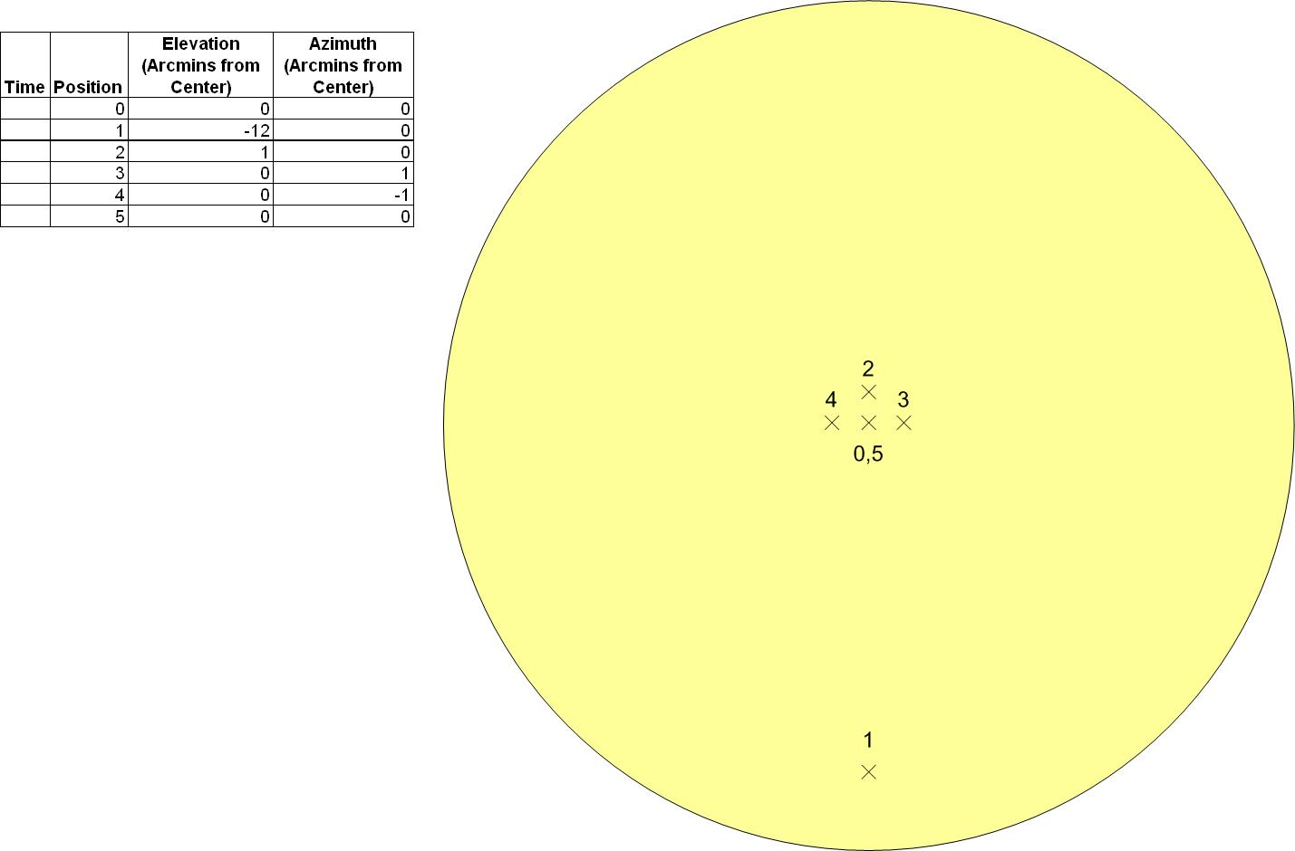

Sunrise: Scan the FOV 1 arcmin in azimuth to one side of the center of the solar image. Scan the FOV across the center of the solar image in azimuth to 1 arcmin on the other side. Scan the FOV diagonally in elevation to 1 arcmin “above” the center of the solar image (azimuth of 0 arcmin). Scan the FOV 12 arcmins in elevation towards the bottom edge (Earth) of the solar image (scan would stop 4 arcmins from the bottom edge). Scan the FOV to the center of the solar image.

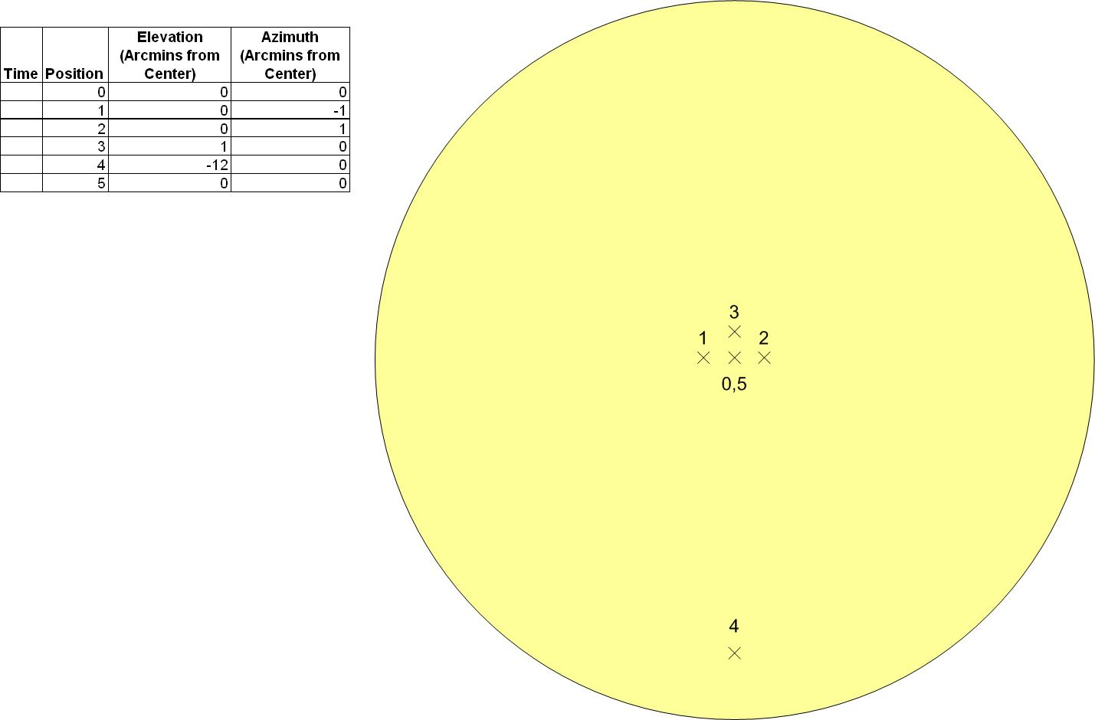

Boresight (sunrise duration = 129 sec., sunset duration = 169 sec.)

Description: Scan the FOV in elevation to 10 arcmins past the edge of the solar image. Scan the FOV across the solar image in elevation to 10 arcmins past the opposite edge of the solar image. Scan the FOV in azimuth to 10 arcmins past the edge of the solar image while returning FOV to 0 arcmins in elevation. Scan the FOV across the solar image in azimuth to 10 arcmins past the opposite edge of the solar image. Return the FOV to the center of the solar image.

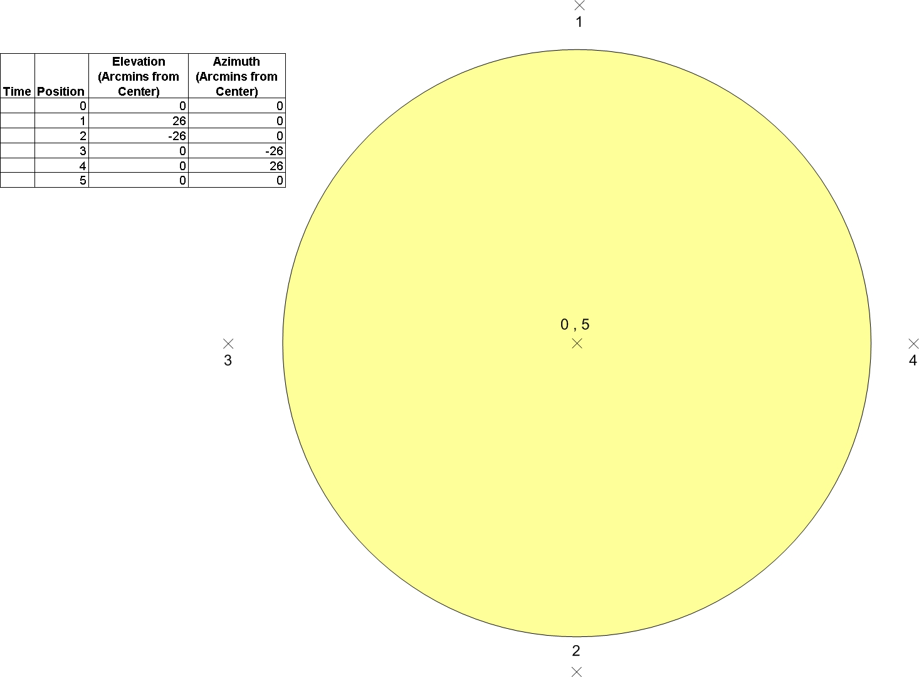

Pixel Flat Field (sunrise duration = 171 sec., sunset duration = 211 sec.)

Description: Place the FPA into Pixel Mode. Scan FOV horizontally through the top edge pixel “box.” Scan FOV vertically through the solar image 3 times while changing azimuth offsets. Scan FOV horizontally through the top edge pixel “box.”

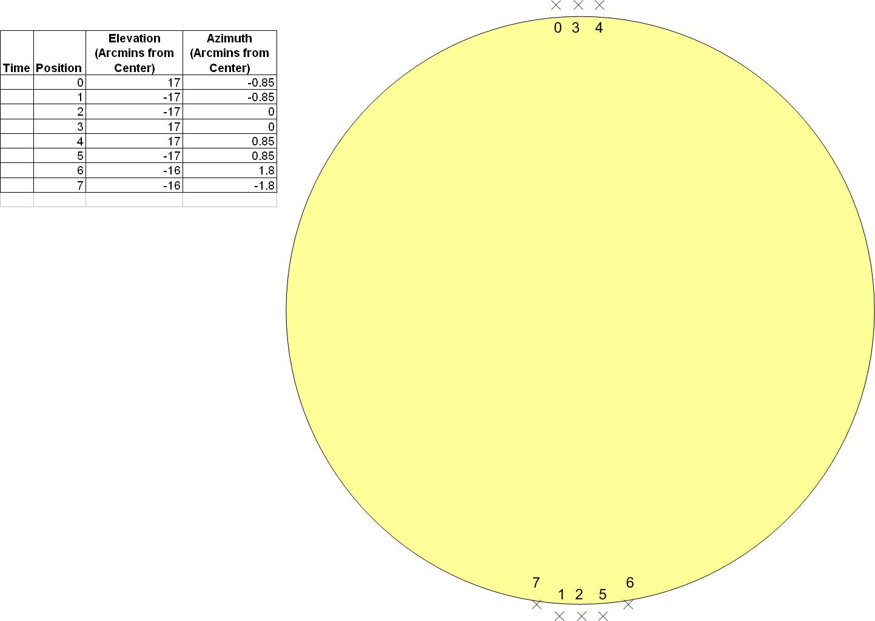

Field of View Mismatch and FOV Location (sunrise duration = 208 sec., sunset duration = 248 sec.)

Description: Scan FOV in elevation to 4 arcmins before the edge of the solar image and offset by 4 arcmins in azimuth. Then using 2 arcmin azimuth offsets, scan the FOV back and forth across the edge in elevation from 4 arcmins on to 4 arcmins off.

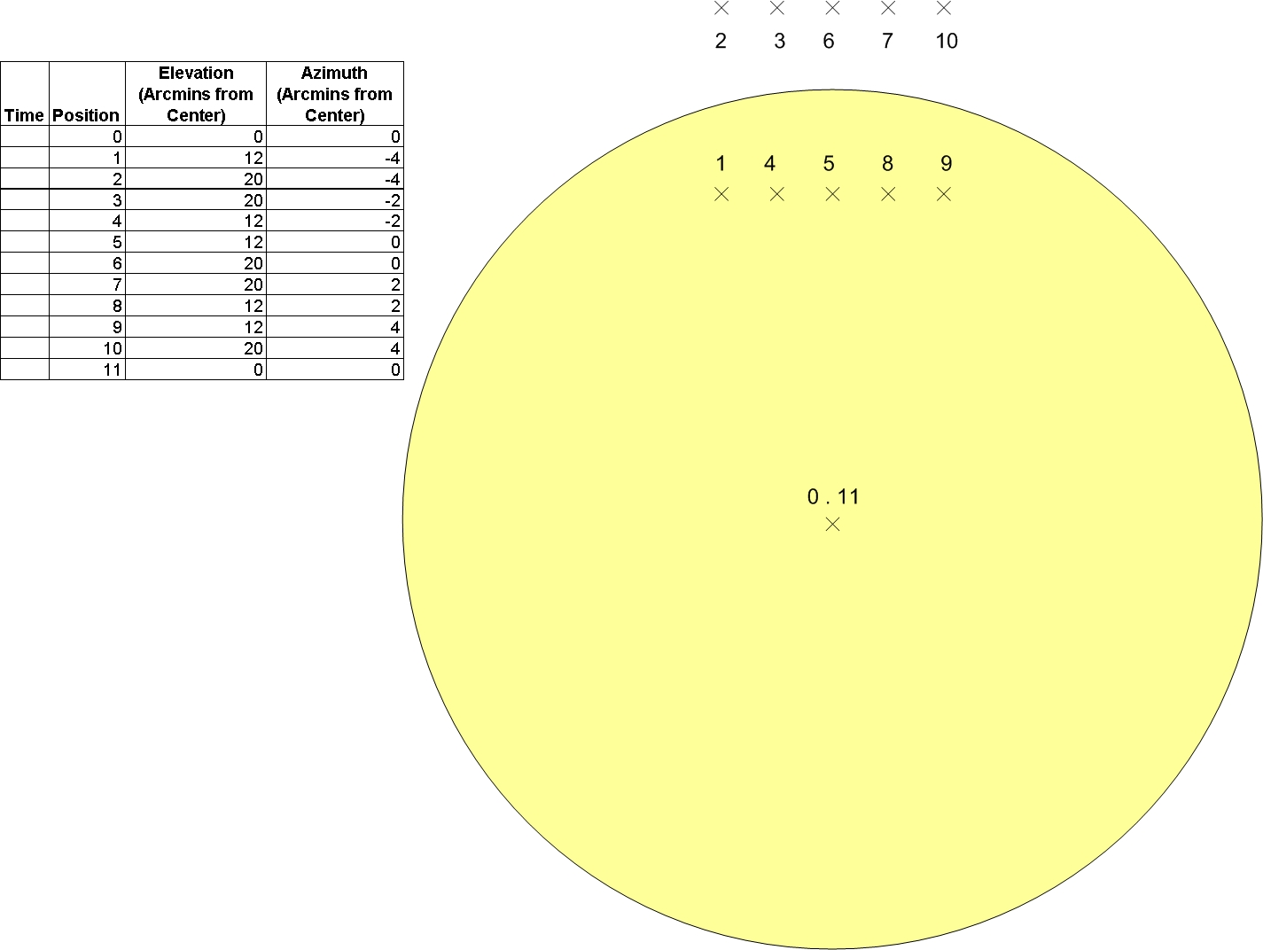

LEOP Low Pass Filter and Zero Offset (sunrise duration = 150 sec., sunset duration = 190 sec.)

Description: Scan FOV in elevation to a point far enough off of the solar image to allow the spacecraft to slew the FOV across the solar image at a minimum of 1 degree per second in elevation.

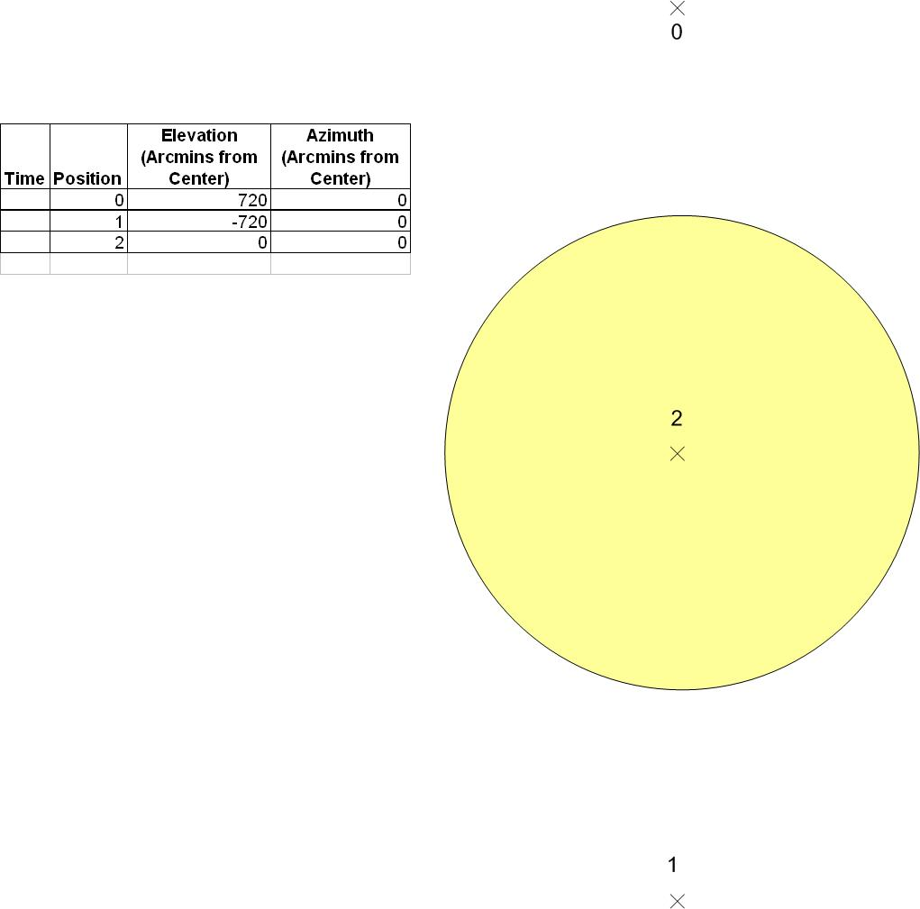

Low Pass Filter and Zero Offset (sunrise duration = 156 sec., sunset duration = 196 sec.)

Description: Scan FOV in azimuth to a point far enough off of the solar image to allow the spacecraft to slew the FOV across the solar image at a minimum of 1 degree per second in azimuth.

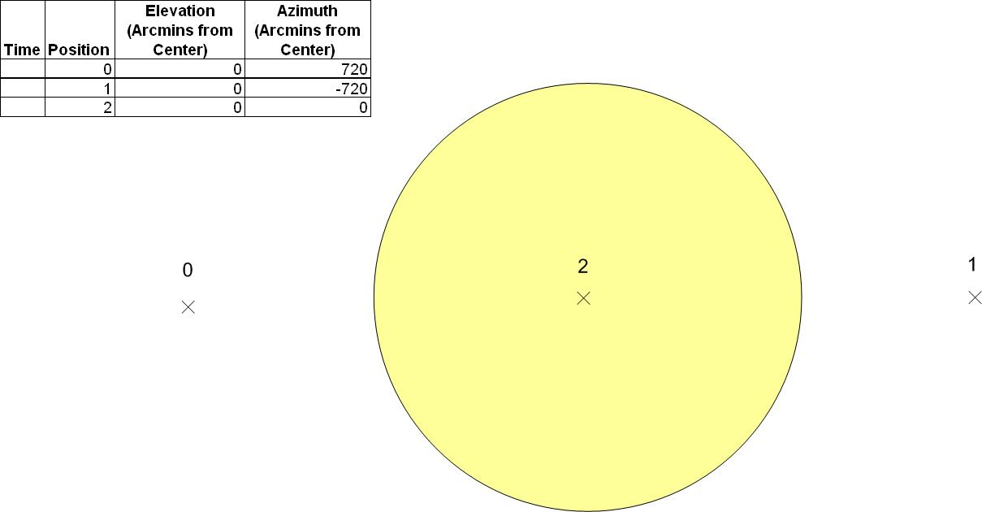

Differential Gain (sunrise duration = 149 sec., sunset duration = 189 sec.)

Description: Scan the FOV 10 arcmins past the edge of the solar image. Scan the FOV to the center of the solar image. Repeat 2 times.

Each time the pointing pauses at the center of the solar image (points 2, 4, and 6), the instrument will be instructed to conduct a balance. The balance adjustment at point 2 will be to max out the delta V signal (~2.5 out of -3 to 3 volts). At point 4 the adjustment will be to minimize the delta V signal (~ -2.5 out of -3 to 3 volts). When pointing reaches the last point, the adjustment will balance the detectors so that the delta V will be at or close to zero (0).

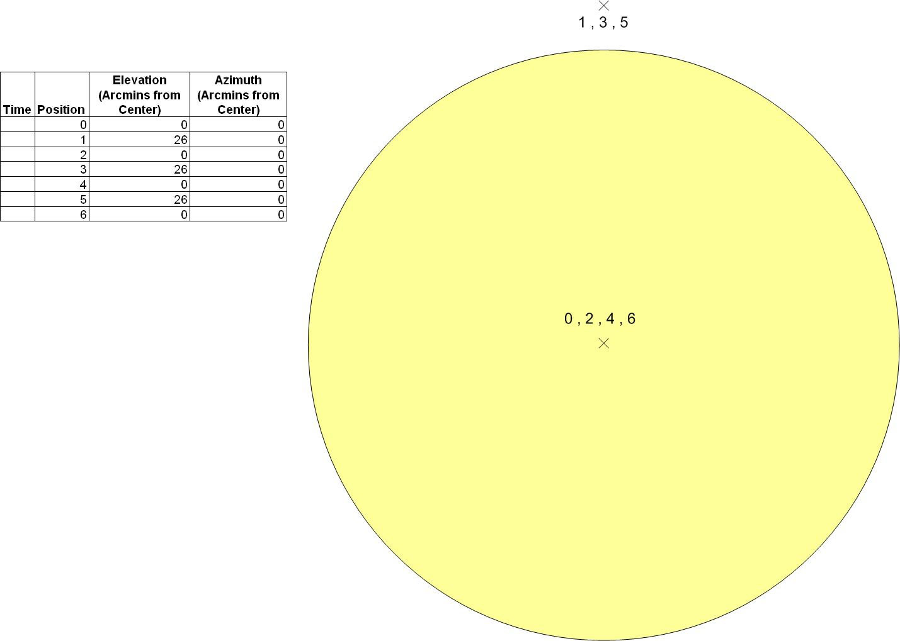

Non-Linearity (sunrise and sunset duration = 60 sec.)

Description: The purpose of the two scans is to alternate between the center of the sun and near the edge of the sun from orbit to orbit over a duration of ~5 days. This should yield enough data to statistically determine equation coefficients necessary to remove non-linearity effects from the SOFIE data set.

On orbit N scan the FOV 12 arcmins in elevation towards the bottom edge (Earth) of the solar image (scan would stop 4 arcmins from the bottom edge). Scan the FOV in elevation across the solar image to 1 arcmin past the center of the solar image. Scan the FOV diagonally to 1 arcmin in azimuth to one side of the center of the solar image (elevation of 0 arcmin). Scan the FOV across the center of the solar image in azimuth to 1 arcmin on the other side. Scan the FOV to the center of the solar image.

On orbit N+1 scan the FOV 12 arcmins in elevation towards the bottom edge (Earth) of the solar image (scan would stop 16 arcmins from the bottom edge). Scan the FOV in elevation across the solar image to 13 arcmin past the center of the solar image. Scan the FOV diagonally to 1 arcmin in azimuth to one side of the center of the solar image (elevation of 12 arcmin). Scan the FOV across the center of the solar image in azimuth to 1 arcmin on the other side. Scan the FOV to a center offset of 0 arcmins azimuth and 12 arcmins elevation.

Only do one of these maneuvers per orbit (sunrise or sunset) in off-season or off-hemisphere. Occultation meas. and Non-Linearity (which replaces Solar Source) should use the same offset in each orbit.

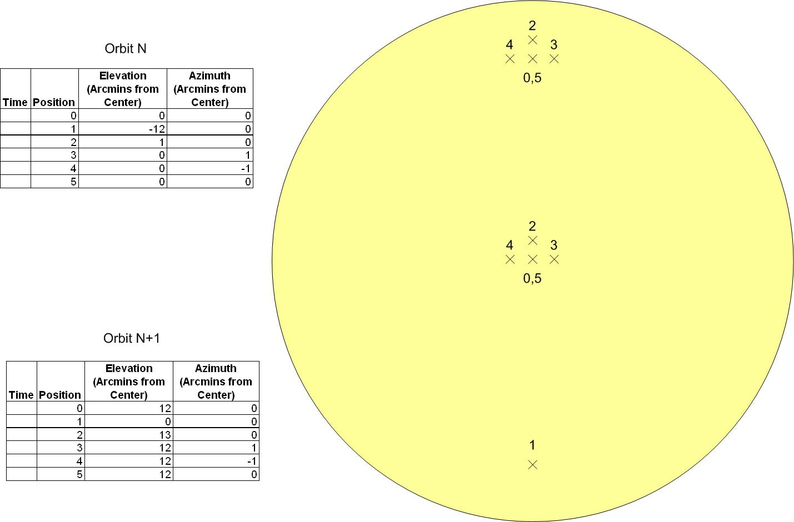
Solar Search (sunrise duration = 243 sec., sunset duration = 283 sec.)

Description: The purpose of this scanning sequence is to monitor an area large enough to “find” the solar image if it appears to be outside of the FOR of the normal scanning sequences. The spacecraft will scan a 4°x4° box and then a larger 8°x8° box. If the solar image is not found within the 8°x8° box, then a new, larger solar search sequence would need to be created.

