Laboratory For Atmospheric And Space Physics

LASP Engineering Division
University of Colorado
Boulder, Colorado

SDC/CDE Calibration Procedure

Document Number:

Written by David James Date 2/2/06

_______________________ _______________________
David James Mihaly Horanyi
Software Engineer Principle Investigator

Rev | Description of Change | Approved | Date
1 | Release Version

Table of Contents
1 Laser Stimulation 3
2 Calibration Summary 5
2.1 Detector Calibration (See chelsey’s section) 5
2.2 Electronics Box Calibration 7
2.2.1 External 7
2.2.2 Internal 9
3 Electronics Box Calibration Data Reduction 9
3.1 External 9
3.1.1 Charge Injection 9
3.1.2 Noise collection 10
3.2 Internal 11
3.2.1 Charge Injection 11
3.2.2 Noise Collection 11

Laser Stimulation
At many times throughout production, testing and integration, the functionality of the detectors needs to be verified. Ideally it would be done by impacting a dust particle and making sure that the resulting charge flow is close to the expected value. However, this is not feasible for a couple of reasons.
First, the impacts cause micrometer sized craters in the detector. Although these do not change the response for the following impacts, and in fact will be seen in flight, it is desirable to start with an unaltered detector for flight.
Secondly, there are only a couple of facilities that would allow for this testing, and requires a great amount of preparation and setup. Thus it is simply not practical to use actual particle impacts for verification if the information can be obtained by a different method.
Fortunately, the information can be obtained by using the pyroelectric properties of PVDF. By locally heating a region of the detector with a laser pulse a flow of charge is created. This heating causes a temporary polarization change. Because of this polarization change there is a charge imbalance causing a flow of electrons simulating a dust impact.
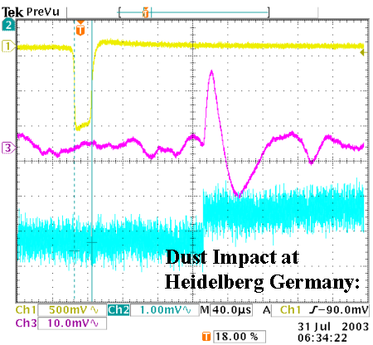
Figure 1: Dust impact response for SDC style detector.

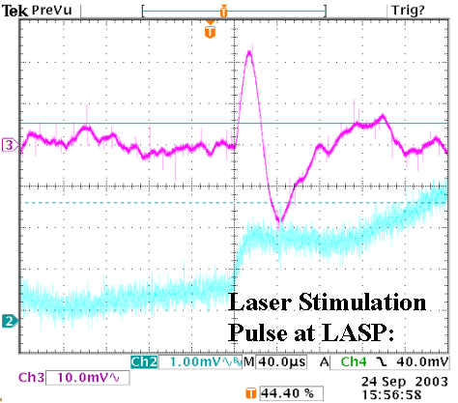
Figure 2: Laser pulse response for SDC style detector.

This pulse method is used both for detector verification and characterization. During the selection process, laser response was used as one factor in determining similar detectors. During the build and testing phases, this was used as verification of functionality. A sample laser energy v.s. response curve is shown below.

Calibration Summary

Detector Calibration (See chelsey’s section)
The SDC detectors are composed of metallized PVDF. This structure consists of an 850Å layer of Al, 150Å of Ni, 28m of permanently polarized PVDF, 150Å of Ni and another 850Å of Al. Connection to the two metallized sides is made via a copper bus wire and silver epoxy (See Figure 3).

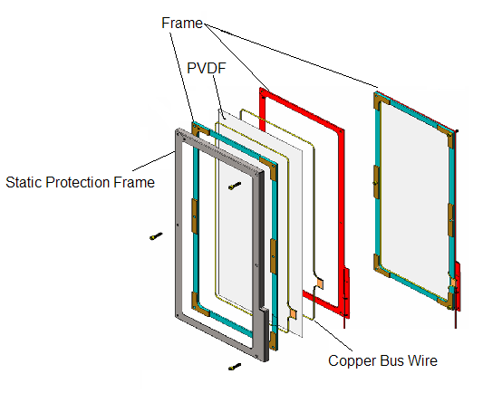
Figure 3: Structure of SDC detector.

The structure is such that a permanently charged capacitor is created. When this structure sustains an impact from a small (~micron), high speed particle (~km/sec) local depolarization occurs near the impact region. This depolarization causes flow of electrons. The dependence of charge flow on speed and mass has previously been characterized by Simpson and Tuzzolino. The first part of SDC calibration is verifying this relationship for a dust impact for the PVDF detectors and making any modifications to the relationship for our specific PVDF design.

To perform this calibration an accelerator capable of accelerating particles to the km/sec range is needed. Thus this part of the calibration is performed at the Max Planck Institute for Kern Physic in Heidelberg, Germany.

At this accelerator facility, particles are charged and accelerated through an electric field. There is a charge pickup tube just before the target region. In this pickup tube the charge on the particle and duration that the particle was in the tube is recorded. The kinetic energy of the particle is given by mv²/2 = q*U where m is the mass, v is the velocity, q is the charge and U is the accelerating potential.

By measuring the amount of time the charge was in the well-defined length of the pickup tube the speed can be determined. Because the voltage of the accelerator is known the above equation can then be solved for mass in terms of v and q. In this way we have an impactor of known speed and mass. The resulting charge flow is determined by a charge sensitive amplifier. The data from Simpson and Tuzzolino is shown in Figure 4.

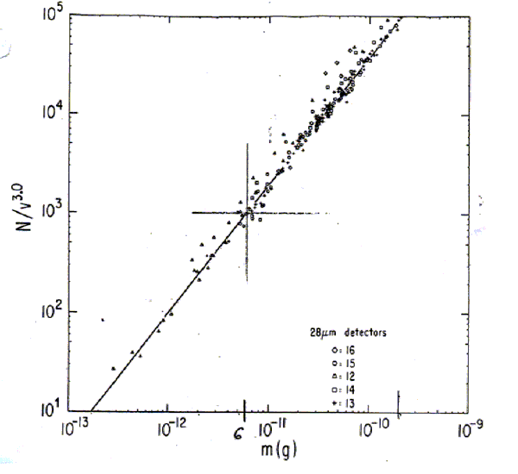
Figure 4: Simpson-Tuzzolino curve. The fit line has a slope of 1.3 on the log-log scale.
With this data Simpson and Tuzzolino discovered an m^{1.3}, v^{3.0} relationship to charge. Our results/equation here.

Electronics Box Calibration

External

Charge Injection (For a complete description of this test see document # 20570-T0-1010.)

When subjected to a flow of electrons, the SDC electronics reports a digital number “DN” based on the specific properties of the SDC analog and digital electronic chains. For the DN to be useful a relationship DN(Q) is needed. However, the electronics box is also susceptible to temperature variation as well as detector capacitance. For these reasons a function DN(Q, T_{d}, C) is needed, where C is the capacitance of the detector, T_{b} is the temperature of the electronics box. The capacitance of the detector has a variation with temperature, thus must be examined during calibration. To establish this relationship the DN out needs to be taken over a range of charge, temperature, and detector capacitances. The schematic of the test to determine DN is shown below.

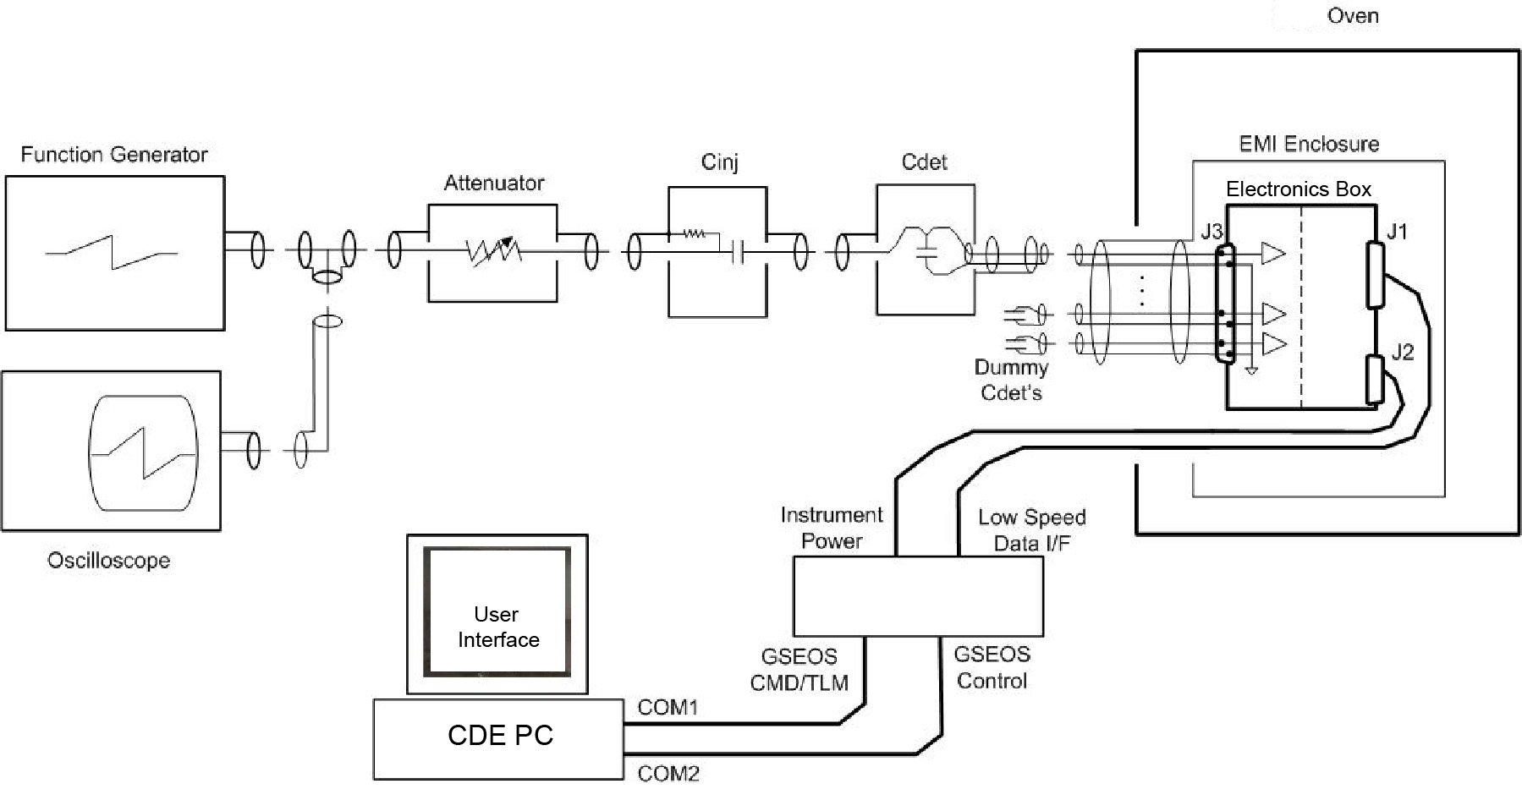
Figure 5: Schematic of external charge injection calibration.
To generate the charge a voltage is put across a capacitor called the charge injection capacitor (C_{inj}). An ideal capacitor (C_{det}) is used to replace the detector capacitance for testing purposes. The replacement of the PVDF capacitor with a mylar capacitor is done to allow control of the C_{det} at ambient temperature, reduce acoustic noise, and have a more robust test setup in general. Dummy capacitors are placed on all channels not being tested to prevent floating leads. For SDC the 3 simulated detector capacitances were 6.8nF, 15nF, and 28nF. The injection capacitors were measured to be 2.08pF and 260pF in circuit.

The four oven temperatures we tested at were 40, 30, 20, -20 ºC. However, the majority of the temperature dependence is associated with the analog electronics. Furthermore, in flight it is much easier to get SDC thermistor values rather than an environmental temperature. Thus for a more direct correlation to the in-flight data the analog temperatures were recorded and used for external charge stimulus injection calibration. These temperatures (corresponding to the above oven temperatures) were 49.9, 40, 34.25,and -7.1 ºC.

For each of these box temperatures, detector temperatures (capacitances), and channels (14), 21 different charges were injected. To perform statistics each of these 21 charges were injected 100 times. This produces a charge in and DN out for 352800 (14 X 3 X 4 X 21 X 100) data points. The data from this test is stored in text files. These text files were then analyzed to find a function for electronics box calibration. For a description of data reduction see section 3.1.1.

Noise Collection
The noise floor of the instrument also needs to be established. On SDC there is the capability to adjust the threshold at which a signal will be recorded. We would like to find the right settings so that the flash is not filled up with noise, but sensitive enough to resolve small particle impacts. To determine the optimal settings, the instrument is placed in a low noise environment and the threshold is dropped to record all stimuli. This data is then analyzed to find settings which will give just less than one false hit per month. For this data analysis see 3.1.2.

Internal

Charge Injection
The SDC instrument also has the capability to inject charge internally. The purpose of this is to allow a reduced version of the full ground calibration in flight for verification purposes.

With this mode we can internally inject 8 different levels between the 21 externally injected values. To inject charge, a voltage is put across a charge injection capacitor in the front of the analog chain. This produces a DN out for a given level and channel. Because the signal chains are in groups of 7, there are two identical injection circuits corresponding to channels 1-7 and 8-14.

To verify functionality of the electronics, the results of DN v.s. level need to be compared to a baseline. To create the baseline, the 8 levels were injected for all channels at the 4 temperatures tested. This data was used to create a function of DN(level, temperature) for the internal injection circuit. (See section 3.2.1)

Noise collection
To fine tune the thresholds determined on the ground a noise determination test needs to be conducted. Ideally this would consist of a similar test conducted on the ground where the threshold was lowered and noise collected for many hours. However due to time and memory constraints, an abbreviated test was created. This test attempts to take points along key points of the threshold v.s. hits/time curve.

For each channel, the threshold is dropped to a pre-determined value for a given time and the hits are recorded. The threshold is then made less sensitive and the time increased. This test is run at 5 different thresholds for every detector.

Electronics Box Calibration Data Reduction

External

Charge Injection
The data collected from the external charge injection is in the form of text files. There is one text file for each detector capacitance (C_{d}), box temperature (T_{b}), and Channel (c). Each of these files contains 21 charge injection values repeated 100 times. To arrive at a final matrix with the calibration information the data needed to be sorted and fit functions found for Q(DN). The specific process is explained below.

The first analysis done on these text files was to separate out the 100 events for each charge amplitude from noise and the remaining 20 injections. This was done by defining parameters in additional text files. A text file was created for each of the T_{b} and c with the time and average amplitude. Using these text files a routine was created to extract data within +/- 3 seconds, data only on the channel of interest, and data below a certain DN (to reduce noise). Because it was found out that the detector capacitance (C_{d}) did not matter (greatest spread was 15%) the detector capacitances were averaged out. Next, text files were created to combine all of the data into one .sav file so that the data will be more easily manipulated in IDL. The data in the .sav matrix (DN v.s. log(q)) was then fit to a 8th, 9th, or 10th degree polynomial. The degree for each was automatically determined by minimizing ². These fit coefficients are then stored in another .sav file called ‘sdc_calibration_matrix.sav’ to be used by the data production routines.

Noise collection
The data from the noise collection for SDC as described in 2.2.2.2 is shown in Figure 6. Noise was collected for 18 hours in an electronically quiet environment. The threshold was set to 65535 allowing for our most sensitive data collection.

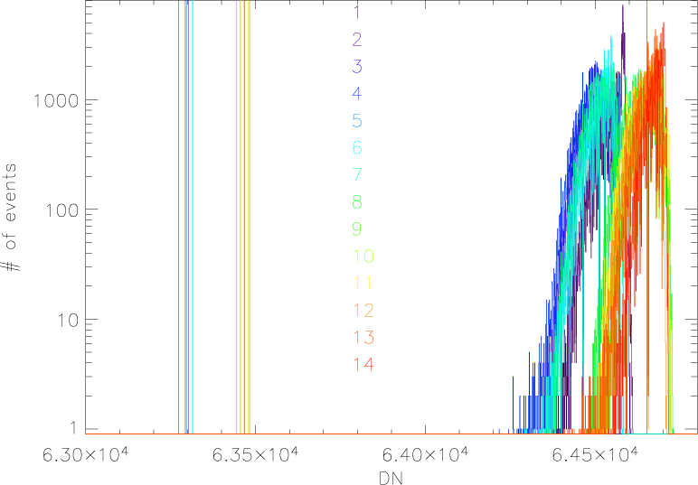
Figure 6: Noise collected for 18 hours at 65535 threshold (allowing all events to register). The vertical lines are the 10⁶ electron level representing science requirements.

To determine thresholds the noise is plotted as hits/time v.s. DN. A fit to this is determined giving a function DN(hits/time). By putting in the desired noise rate (one noise hit per month for SDC) a suitable threshold is calculated.

Internal

Charge Injection
For the internal charge injection a baseline needed to be established. When conducting the external charge injection, at the end of each box temperature test an internal charge injection test was conducted. The data produce is DN and voltage out.

The only variable for input charge is the detector capacitance. However, as mentioned earlier, the variance due to this is extremely small. Thus Because we know that the same voltage is put across the same capacitor for any given level, the charge as a function of level should be independent of external parameters. The DN out in this case should simply be a function of analog electronics temperature. Thus a .sav matrix with level and fit coefficient was created to compare to the baseline. By giving a box temperature, the baseline is shifted and should match up with the flight DN v.s. level curve in flight. A sample baseline and flight data curve is shown in Figure 7.

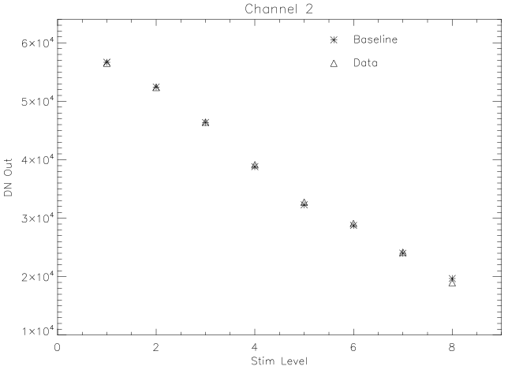
Figure 7: Channel 2 flight and baseline curves.

Noise Collection
To characterize the noise floor in flight an abbreviated version of the ground noise collection test is performed. Ideally this test would lower all of the thresholds to their most sensitive value and store that data for as long as possible. Due to memory constraints, this is not feasible. To deal with these memory constraints noise is collected noise at four different thresholds. For each of these thresholds, a timeout and a maximum number of hits is determined from ground noise collection.

The five thresholds, timeout values, and maximum number of hits are adjustable. The values as of 6/10/06 were
Threshold Timeout Hits
- 62000 10 10
- 63000 20 20
- 64000 30 30
- 65000 40 40
- 66000 50 50

Thus, for the first test channel 1 is lowered to 62000, the first threshold. Noise is collected until either the timeout or the maximum number of hits is reached.

The purpose of this process is to determine a threshold for each channel based on the noise floor. To satisfy requirements, SDC must record no more than one false hit per month. To determine this, the hits per time is recorded for each of these thresholds on each channel. By fitting a function to this data, a threshold can be calculated for the one hit per month rate.

REF
1. Tuzzolino, J.A., 1983. “Pulse amplitude method for determining the pyroelectric coefficient of pyroelectric materials.” Nuclear Instruments and Methods, 212, 505-516.

